Detailed Design Change Pack

Communication Detail
Comm Reference: | 3165.1 - VO - PO
Comm Title: | XRN5482 - Replacement of reads associated to meter asset technical details change or update (RGMA) – Detail Design
Comm Date: | 17/04/2023

Change Representation
Action Required: | For Representation
Close Out Date: | 02/05/2023

Change Detail
Xoserve Reference Number: | XRN5482
Change Class: | Functional Change
*ChMC Constituency Impacted: | Shipper all classes  *Assumed impacted parties of the proposed change, all parties are encouraged to review
Change Owner: | uklinkdelivery@xoserve.com
Background and Context: | Change Background:  This change is related to replacement of RGMA (Review of gas and metering arrangements) reads. Shippers are required to provide MTD (Meter Technical Details) updates to the CDSP (Central Data Service Provider), the recognised route for this being RGMA files, ONJOB and ONUPD.  The source of these MTD updates is the Meter Asset Manager (MAM)/Meter Equipment Manager (MEM). Where an onsite activity (install, exchange, or removal) is completed or an inconsistency is found in the MTDs, the MAMs issue the updates to the Supplier, the Supplier subsequently passes these updates on to the Shipper. The supplied MTDs should also include a read, for each metering asset, where there has been a physical action at site and details submitted via an ONJOB file. For an update RGMA flow via ONUPD the read is not mandatory and, where not supplied to the CDSP, the CDSP will generate and issue an estimated read(s) where necessary.  These estimated, actual readings and the resulting energy are used in downstream settlement processes by the CDSP. The actual and estimated reads both can be replaced as part of this change.  It has been highlighted that the RGMA files provided to Shipper Users by MAMs may not always include the reads required or, those that are included, may be found to be incorrect. As the population of data within the source files is, in most cases, manually obtained and entered, there is scope for human error. It is also noted that the accuracy of a read estimated by the CDSP, because of one not being provided within a ONUPD, is dependent upon the read history and the AQ (Annual Quantity) at the given Supply Meter Point (SMP) within the Supply Point Register (SPR). As stated above, these reads cannot be replaced, even were identified as being incorrect, which can lead to issues in settlement that can only be resolved through the consumption adjustment process which has a high level of manual effort, for both the Shipper User and the CDSP. Where RGMA reads are submitted to estimate or satisfy shipper transfer reads and an inaccuracy is identified, this could result in inaccurate final and opening billing, to the end consumer, and a large delay in being able to correct this. As part of this change the certain downstream processes like SMP reconciliation, AQ calculation, invoicing etc. will be impact assessed to identify any updates needed to those processes. The scope of this change is only for Class 3 and Class 4 SMPs. The RGMA process in general is not impacted, this change introduces the facility to replace the RGMA reads.  Business benefits:  Shipper Users will be provided with the mechanism to correct inaccuracies in RGMA read history, aiming to reduce the need for manual effort and time required to process a consumption adjustment.  This is to reduce the levels of inaccurate data and the impact on the incoming shipper, risk of read data issues being passed on to subsequent Shipper Users, following a transfer of ownership, making them increasingly difficult to resolve and in turn, improve the end consumer switching experience.  The overall quality of read data:  • Will improve with the introduction of the RGMA replacement read functionality  • AQ calculation will be more accurate when subsequent reads received trigger the AQ process  • Will reduce the number of rejected reads created because of an inaccurate Opening/Report RGMA read  • Will support Shipper Users in ensuring SMP RGMA read histories are correct  • Improved Reconciliation and billing because of actual read

Change Impact Assessment Dashboard
Functional: | - RGMA Reads  - SMP Reconciliation  - Amendments Invoicing  - UK Link file format  - Reporting
Non-Functional: | - Transaction Volume  - Data Volume and Capacity  - Batch Schedule  - Performance  - SLA and response time [new process in line with BAU process]  - Data archival and replication  - Monitoring and alerting
Application: | - SAP ISU (UK Link)  - SAP BW (Reporting)  - SAP PO  - GES (Gas Enquiry Services)  - Discovery (previously DDP (Data Discovery Platform))  - Market Flow
User(s): | - Shippers
Documentation: | - RRP file format – RGMA read replacement file  - RRR file format – RGMA read replacement response file
Other: | N/A

File
File | Parent Record | Record | Data Attribute | Hierarchy or Format  Agreed
RRP | n/a | n/a | n/a | Hierarchy
RRP | R20 | R21 | New records | Format
RRR | n/a | n/a | n/a | Hierarchy
RRR | R22 | S72 (not modified) | New record | Format

Change Design Description
As part of this change shippers will be able to provide the replacement reads for the RGMA reads present in CDSP systems. Current functionality does not allow the replacement of RGMA reads. This change will introduce the mechanism to receive, validate, store, and acknowledge the replacement reads for RGMA reads.

Following the implementation of this change, shippers will be able to amend the RGMA reads by sending a valid RGMA replacement read request for an existing estimated or actual RGMA read for class 3 and class 4 for meter only sites (SMPs must be class 3 or 4 on the RGMA read effective date), where the RGMA replacement read date is same as the original RGMA read effective date. For a site where a meter and a convertor both are present in such case any RGMA replacement read will be rejected. Any RGMA read replacements related to Prime and Sub sites will also be rejected.

The required RGMA read replacement will be sent in a newly designed file. There will be validation logic built in the system for the new file and based on the outcome, the read details will be updated in the UK Link system. The new read will trigger the reconciliation process and billing & invoicing will be performed. Read details will be sent to SAP BW and other reporting systems. This will also be displayed in the GES screens and Discovery (previously DDP) systems. If required validations are not met the read will be rejected and a rejection response will be sent back to the requesting shipper.

New File Format / Existing File Transfer Mechanism:

The new RGMA replacement read file (RRP) is received by the CDSP systems from the shippers via existing IX/EFT route. Once the file is received in EFT (Enterprise File Transfer), it will be validated and placed in the inbound folder for Marketflow to pick and process. Marketflow will perform the file format validation which includes optionality/mandatory field checks, field type validations etc. If the file format validations fail ERR/FRJ file will be generated

Once the read validations are passed the read will be updated in the UK Link system and will be marked with a new read type as ‘K.’

RGMA read replacement response file (RRR) will be sent to the shipper over EFT/IX. Where an RGMA read replacement request is accepted or rejected, a response will be sent back to the requesting shipper.
The accepted RGMA replacement read will flow to the downstream systems to keep the data in all required applications in sync and up to date.

Accepted RGMA replacement read will also feed into downstream processes like SMP reconciliation, billing & amendment invoicing processes. There is no change to the consumption adjustment process and replacement RGMA reads will not trigger monthly rolling AQ calculation.

New record types:

The following record types are introduced as part of this change.

File hierarchy:
RRP (RGMA Read replacement File) Hierarchy – Direction Shipper to CDSP

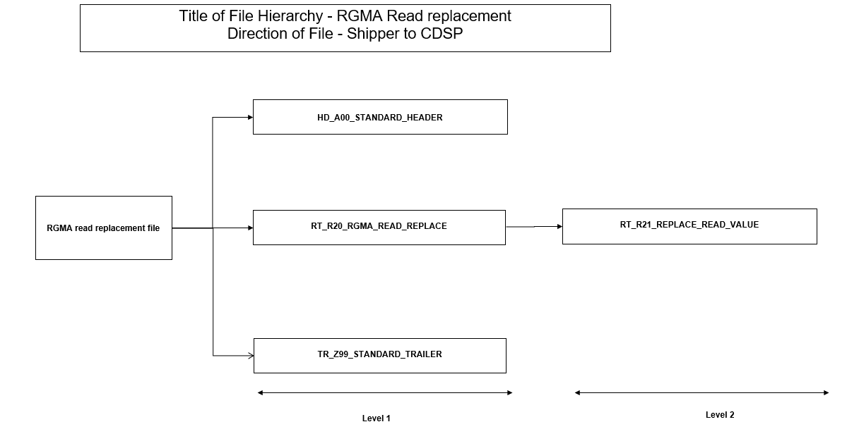

RRR (RGMA Read replacement response file) Hierarchy – Direction CDSP to Shipper

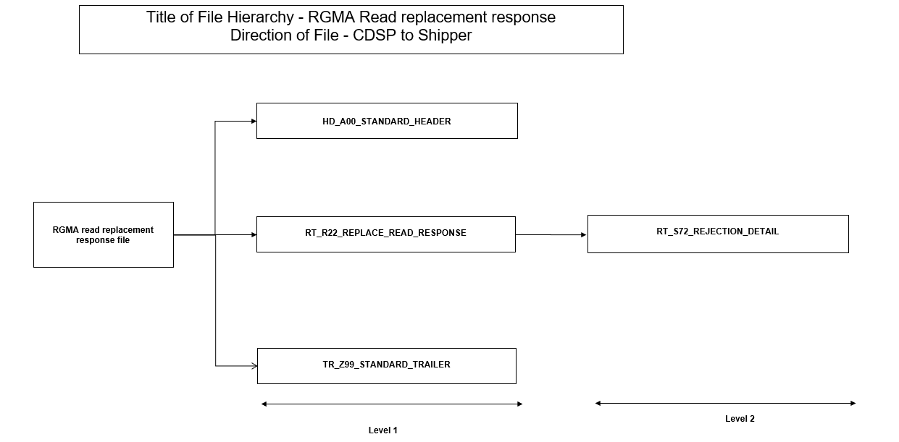

New Read rejection codes introduced as part of XRN5482

Where possible existing reason codes have been reused. Following are the new read rejection codes which are introduced as part of this change.

Read Rejection Code | Read Rejection Text
RRP00001 | Read source not provided as an agreed read
RRP00002 | RGMA replacement read date is prior to LIS date
RRP00003 | MPRN is part of MOD424 arrangement for the read date
RRP00004 | Submitting User is different from the user who submitted the original RGMA transaction
RRP00005 | Submitted RGMA replacement read and/or round the clock (RTC) is same as the existing read/RTC
RRP00006 | Read date lies at either start, end or within the faulty period
RRP00007 | RGMA Read replacement is not allowed for isolation and reconnection
RRP00008 | RGMA Read replacement is not allowed for convertor device
RRP00009 | RGMA Read replacement is not allowed for prime or sub meters

Attaching the Shipper Rejection Document current version v13FA.
[Please Note:] The current version contains updates for other changes.

Dummy file (example)

We are not recommending Market Trials as part of this change however we are including the example dummy files with dummy data for better understanding.

Scenarios where the RGMA reads cannot be replaced

There are some of the key scenarios where the RGMA reads cannot be replaced and in such an event the reads will be rejected, and rejection response will be sent back to the originator.

- Duplicate (identical) reads for a read date are not recorded on the Supply Point Register. An RGMA replacement reading will be rejected, where the existing reading and/or TTZ (Times Through Zero) on the billable device is the same as the one provided in the read replacement file – RRP00005

- An RGMA read replacement request where the read date does not fall on the shipper registration date (and therefore does not need to be agreed) but the requesting shipper has indicated that the reading has been agreed, the request shall be rejected for that reason - MRE00403

- If the read replacement date is before the Line in sand (LIS) it is rejected - RRP00002

- The RGMA read replacement request is not accepted if the replacement read date is either at the start or the end reading of a consumption adjustment period, or it lies within a consumption adjustment period - MRE01005

- The RGMA read replacement request is not accepted if the replacement read date is either at the start or the end reading of an active fault or lies within the faulty period – RRP00006

- The RGMA read replacement request is not accepted where the read replacement date is at the start, end or lies within the bypass effective period - MRE01025

- The RGMA read replacement request is not accepted where the read replacement date is at the start or end of a check to check reconciliation period - MRE01006

- Reject the RGMA replacement reading for the isolation/ reconnection where the meter status is capped/ clamped or reconnected on the RGMA effective date and/or subsequent read activity is present - RRP00007

- Where the same meter has been reinstated (GSR MOD424 – Same shipper and same meter), we reject the RGMA read replacement request for removal, or the installation read - RRP00003

- If there is a convertor present on the RGMA read replacement date it will be rejected - RRP00008

- The meter is not classified as class 3 or class 4 on the RGMA read replacement effective date - MRE01017

- RGMA read replacement will not be allowed for Prime or sub sites - RRP00009

RFA (Request for Adjustment) process will still be available in case the RGMA read replacement process fails to update the reads in the UK Link system through this proposed new process.

TTZ scenarios

As part of XRN5482 the opening RGMA reads can be replaced. Present system does not allow an opening RGMA read to be replaced. Hence new volume calculation logic is defined to derive a TTZ (Wherever applicable) to calculate the forward volume between the replaced RGMA read and the next read. This document lists the possible scenarios and the appropriate logic for volume calculation.

- If the subsequent read is an actual read existing BAU (Business as Usual) logic for tolerance and volume calculation will be followed. TTZ provided along with the read replacement will be used for volume calculation.

- If the next read is estimated, then the new logic detailed below will be used. TTZ provided along with read replacement will not be used, however a derived TTZ will be used instead.
New forward volume calculation logic:
If Replacement Read Index – maximum read index for asset (as an absolute) < Replacement Read index, then TTZ = 01 else TTZ = 00

There are some rejection scenarios for e.g., if the requested RGMA replacement read value is higher than the subsequent actual read value, the request will be rejected as part of read validation.
There are exception scenarios. e.g., If the RGMA replacement read is replacing an OPNN/OPNX and the replacement read has clocked over but the subsequent estimated read hadn’t clocked over, the new volume calculation logic may derive an incorrect volume. The shipper can either replace the estimated read or can raise a RFA to correct the volume.

Customer is advised to monitor the consumption information issued via the amendment billing supporting information files so that any incorrect volumes can be corrected via the adjustment process.

UNC (Unified Network Code) Validation Rules amendment

We shall look into the details of the UNCVR (UNC Validation Rules) document and see if any required update needs to be done to the details and we shall update it accordingly.

SAP BW reports catalogue

The SAP BW reports will be impacted by the change. RGMA replacement reads will need to flow into some of the SAP BW reporting catalogue. We are assessing the full impact of this RGMA Read replacement in these reports and once this is completed, we shall confirm the changes.

Discovery (previously DDP)

It has been identified that the following Discovery (previously DDP) reporting dashboard will need to be updated based on the change XRN5482.

1. Shipper Asset / RGMA Dashboard
The Asset Insights / RGMA dashboard in Discovery will be impacted. The dashboard will need to be updated to reflect the new rejection reasons.
2. Shipper Read Rejections Dashboard
- Read Rejection by Rejection Reason will need to be updated to reflect the new read rejection reasons.
- Read Rejections by Read Type will need to be updated to Include the read type.
3. PAFA Read Rejections Dashboard (Industry Reporting)
The PAFA Read Rejections Dashboard in Discovery will be impacted. The dashboard will need to be updated to reflect the new rejection reasons.

GES Online Portal (for information)

The GES Online Portal will be updated to display accepted replacement RGMA reads, along with the replaced RGMA read where applicable within the read history and read details screens. The asset history details will also be updated to reflect any accepted replacement RGMA opening or closing reads.

Where the Read Type is displayed, accepted replacement RGMA reads will be identifiable by a new Read Type of K with all other associated fields being populated in line with existing logic, such as read reason which would remain as OPNN, OPNX, N, FINX, etc. aligned to the original RGMA activity reason. 'Any replaced RGMA read will be updated to ‘Inactive’ so that they are identifiable as being replaced, and the new read will be shown as 'Active'.

We shall work with RECCO and look into how to establish if any changes are required in the REC (Retail Energy Code) in account of the above.

Service Line Impact

The following existing Service Lines are relevant to the change XRN5482:

DS-CS-SA4-17 - validation of meter readings, including Updated Meter readings (and submission of the outcome to the User)
ASGT-CS-SA4-10 - actions undertaken because of receiving a Valid Meter Reading, Check Read or Updated Meter Reading, including Offtake Reconciliation and AQ calculation

No new service lines are required to incorporate this change.

Associated Changes
Associated Change(s) and Title(s): | GES CR Number [TBC]

DSG
Target DSG discussion date: | 24.04.2023
Any further information:

Implementation
Target Release: | November 2023
Status: | Scope for ChMC approval

Detailed Design Industry Response
«RangeStart:HDS»
Change Representation
(To be completed by User and returned for response)
User Contact Details: | Organisation: | «h1_organisation»
 | Name: | «h1_name»
 | Email: | «h1_email»
 | Telephone: | «h1_telephone»
Representation Status: | «h1_userDataStatus»
Representation Publication: | «h1_consultation»
Representation Comments: | «h1_userDataComments»
Confirm Target Release Date? | «h1_targetDate» |  | «h1_userDataAlternative»

Xoserve’ s Response
Xoserve Response to Organisations Comments: | «h1_xoserveResponse»

Please send the completed representation response to uklink@xoserve.com

«RangeEnd:HDS»

Change Management Committee Outcome
Change Status: | ☒ Approve | ☐ Reject |  |  | ☐ Defer
Industry Consultation: | ☒ 10 Working Days |  | ☐ 15 Working Days
 | ☐ 20 Working Days |  | ☐ Other [Specify Here]
Date Issued: | 17/04/2023
Comms Ref(s): | 3165.1 - VO - PO
Number of Responses: | 1
Solution Voting: | ☒ Shipper |  |  | Please select.
 | ☐ National Grid Transmission |  |  | Please select.
 | ☒ Distribution Network Operator |  |  | Please select.
 | ☐ IGT |  |  | Please select.
Meeting Date: | 10/05/2023
Release Date: | Major
Please send the completed representation response to uklink@xoserve.com

Version Control

Document

Version | Status | Date | Author(s) | Remarks
V0.1 | Draft | 27.03.2023 | Correla BA | First Draft
V0.2 | Internal review | 11.04.2023 | Correla BA | Document reviewed by internal team
V1.0FA | For Approval | 14.04.2023 | Correla BA | Sent for approval

