Detailed Design Change Pack

Communication Detail
Comm Reference: | 3265.3 – VO – PO
Comm Title: | XRN 5614 - Improving IGT SMP New Connection Process to support accurate and timely Supplier Registration
Comm Date: | 15/03/2024

Change Representation
Action Required: | For representation
Close Out Date: | 03/04/2024

Change Detail
Xoserve Reference Number: | XRN5614
Change Class: | Functional Change
*ChMC Constituency Impacted: | IGTs  Shippers (all classes)  *Assumed impacted parties of the proposed change, all parties are encouraged to review
Change Owner: | uklinkdelivery@xoserve.com
Background and Context: | Creation and registration of IGT Supply Meter Points is an activity that takes place between IGTs, CDSP (Central Data Service Provider), Shippers and Suppliers and the Retail Energy Code (REC) Central Switching Service Provider. Shipper and Supplier organisations use the data that is supplied via the IGT Supply Meter Point Creation and IGT Supply Meter Point Amendment process to undertake registration activities in accordance with their Retail Energy Code obligations.  IGTs provide the necessary datasets that Shipper and Supplier organisations use to create End Consumer accounts within their related IT systems, which trigger the associated registration activities.  The data supplied in this process flows through IGTs from the respective Property Developer, who reaches an agreement with a Shipper to take responsibility for the associated offtake at the appointed premises before notifying the IGT of any changes to their previously elected Shipper. Where this data becomes inaccurate or outdated it can lead to delay in ensuring accurate registration details are recorded against IGT Supply Meter Points.  Where a Supplier has enacted a registration request with the REC Central Switching Service Provider, the CDSP receives this information and no longer recognises the site as being at a ‘pre-registered’ state. Currently, the CDSP is unable to facilitate the notification to Shippers where IGTs are informed by Developers that Shipper and Supplier details have been amended, which can result in lengthy delays.  Hence CDSP require a mechanism to ensure this information can be passed to the relevant Shipper organisations to allow the appropriate action to be taken.  Also, any discrepancies relating to registered Shipper and Supplier at new connection premises can lead to challenges in ensuring metering data and related organisation data MAM (Meter Asset Manager) / MAP (Meter Asset Provider) that is understood and recognised between multiple industry parties in the central industry systems.  This change will support accurate and timely elected Shipper and Supplier registration for IGT (independent gas transporters) MPRN (meter point reference number) installation and registration process.  Anticipated benefits, data analysis and related impacted scenarios are outlined in the section below and at the request of DSC Change Management Committee this has been included within this Detailed Design Change Pack to aid parties’ assessment of the proposed solution.  Analysis, Historic Trends and Scenarios;  Analysis has taken place between CDSP and IGT parties, to identify scenarios and volumes of impacted IGT Supply Meter Points – this has identified the following points;  - Analysis performed over six year period (2017 – 2023 inclusive)  - Noted that data was not able to evidence a specific trend of instances during the analysed period due to status of data being archived  - Also noted reporting between June 2017 and October 2018 only residual instances of misaligned datasets (approx. 12 – as reported by Xoserve to IGT UNC Workstream in October 2018)  - This is supportive of anecdotal views which have expressed that instances of misalignment have likely increased over time (i.e. 2019 onwards)  - Based on extrapolation of data provided by IGTs, approximately 4,500 MPRNs have been impacted by instances where Shipper details have changed ‘post registration but prior to meter installation  - In addition, a further approx. 8,300 are currently reflected as available in UK Link for registration purposes but are associated to ‘written off’ plots  - Historically there have been circa 200,000 MPRNs created on IGT Networks annually  - New housing quotas expected to remain consistent in the short to medium term (2024, 2025(+))  - Anticipated more agility will be needed to support Developer plans on new connection sites (e.g. choosing Heat Pumps over traditional gas heating)  Anticipated Benefits:  - enable CDSP to facilitate the notification to Shippers where IGTs are informed by Developers that elected Shipper and elected Supplier details have been amended  - reduce length of time taken to resolve queries relating to Shipper and Supplier registrations on IGT Supply Meter Points  - alleviate challenges different industry parties face, such as billing of assets, metering data, IGT transportation charges and accuracy of settlement and switching processes, by supporting the reduction of misaligned data across multiple sources (IGT, CDSP, CSS)  - lesson the likelihood of end consumers being impacted when taking supply at newly connected IGT Supply Meter Point  - Reduces likelihood of IGT Supply Meter Point being inadvertently seen as available to register (where plots have been written off and MPRNs become extinct – increasing agility to response to changing market needs)  NB: This information has been shared with DSC customers at Change Management Committee on Wednesday 13th March – and has been included within this Detailed Design Change Pack to aid parties’ assessment of the proposed solution

Change Impact Assessment Dashboard
Functional: | Supply Point Registration  Reporting/ Data extract (one time)
Non-Functional: | None identified
Application: | SAP ISU
User(s): | Shippers (all classes)  Suppliers  IGTs
Documentation: | IGT rejection code document
Other: | None

File | Parent Record | Record | Data Attribute | Hierarchy or Format  Agreed
None | None | None | None | None

Change Design Description

As part of this change IGTs will be able to send updates to elected Shipper and Supplier details and it will be accepted and stored in the CDSP systems for the registered sites only until the first meter installation. CDSP will notify the Shippers and Suppliers for any update to the elected/de-elected Shipper and Supplier.
UK Link - When an IGT submits an amendment file .IMA (IGT_SMP_AMENDMENT_REQUEST), validation will no longer be applied to check if the site is already registered or there is an in-progress registration request. The amendment .IMA file will be changed to accept Elected Shipper/ Supplier amendments. Validations for rejection code IGT00924 (Meter Point cannot be amended following Shipper registration) will be removed from the .IMA file validation for elected Shipper/Supplier amendment. Please note this validation will still occur when a cancellation request is received.

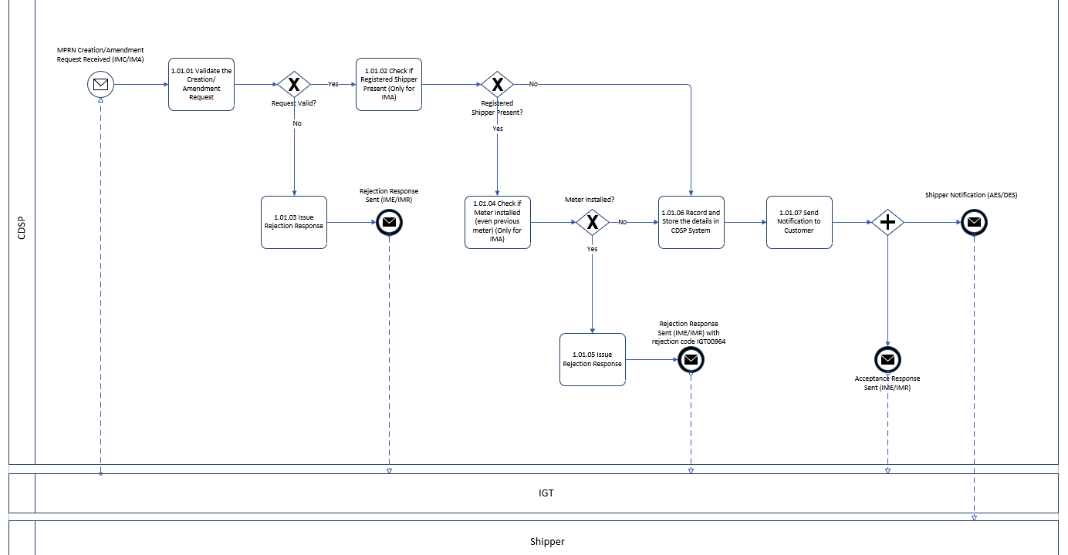
The .AES (Appointed Elected Shipper Notification) and the .DES (De-appointed Elected Shipper Notification) notifications will be issued respectively to the newly elected and de-elected Shipper. AES/DES is only sent the relevant shippers and where there is a different shipper registered, they will not be notified of any changes to the elected shipper/supplier Only if the IGT updates the current registered shipper as the elected shipper, the AES will be triggered to the registered shipper.
A new validation will be introduced in .IMA file to reject the elected Shipper/suppler amendment request - if meter is present for the site or there was a meter earlier (presently no meter), during processing of the .IMA request. The meter check will be performed for all elected Shipper/Supplier update irrespective of an active/in-progress registration during .IMA processing. It will also be applicable if the request is to set elected Shipper/Supplier value to blank from a valid value or the request is to set a valid elected Shipper/Supplier value where presently no elected Shipper/Supplier present for the MPRN.
New rejection code, IGT00964 (Meter Point has current or historic device, elected Shipper/Supplier updates are not permitted) is introduced as part of this change. The rejection notification will be sent in .IME (IGT_SMP_AMENDMENT_RESPONSE) response to IGT. Attached the updated version for approval.
If registration data is found and the .IMA request also has updates for Market sector code, MAM, and Original meter point AQ(RPC), then no updates will be done for Market sector code, MAM and AQ Roll value. Only Original meter point AQ value will be updated along with elected Shipper/Supplier.
There are no impacts to the downstream processes such as meter installation and meter point registration process.

Report (One-time adhoc) - IGT Portfolio Report for Elected Shipper Reconciliation:
To allow IGTs to identify the current elected Shippers and Suppliers as stored in UK Link system, a one-time reconciliation/snapshot report/ data extract from SAP ISU will be generated. This will be produced only for live MPRNs (Meter Point Reference Number) for each IGT and if the site is having unregistered meter point or a no meter installed at all. This will not be a scheduled report and if required in future Operations team can be contacted to generate the details. If at present there is a device attached to an MPRN or there was a device attached earlier, then these MPRNs will be excluded from the report. MPRN statuses that will be excluded from the report are e.g., dead, capped/clamped, extinct. Report will be produced in CSV format which can be viewable in excel sheet. If the IGT portfolio is more than 200,000 MPRNs, then each file will be created with 200,000 MPRN entries.
The following fields will be provided within the report:
- MPRN
- CSEP (Connected System Exit Point) ID
- Latest Elected Shipper
- Latest Elected Supplier
- Latest Registered Shipper
- Latest Registered Supplier
- Latest formal registration date
- IGT short code
- Market sector code
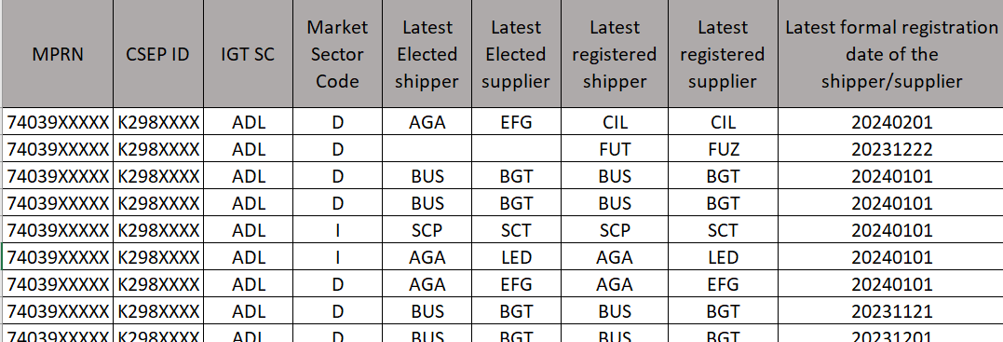
Date of generating this extract will before the Go Live Date, exact date will be confirmed nearer to the Go Live Date. The extract will be sent by CDSP through emails to the respective IGTs for their specific portfolios.

Associated Changes
Associated Change(s) and Title(s): | NA

DSG
Target DSG discussion date: | 25.03.2024
Any further information: | To discuss any comments provided from the Detailed Design Change Pack representations

Implementation
Target Release: | To be confirmed
Status: | For approval

Industry Response Detailed Design «RangeStart:HDS»
Change Representation
(To be completed by User and returned for response)
Please consider any commercial impacts to your organisation that Xoserve need to be aware of when formulating your response

User Contact Details: | Organisation: | «h1_organisation»
 | Name: | «h1_name»
 | Email: | «h1_email»
 | Telephone: | «h1_telephone»
Customer decision on Change Pack: | «h1_userDataStatus»
Commercial impacts: | «h1_commercial_impacts»
Representation Publication: | «h1_consultation»
Representation Comments: | «h1_userDataComments»

Xoserve’ s Response
Xoserve Response to Organisations Comments: | «h1_xoserveResponse»

Please send the completed representation response to uklink@xoserve.com

«RangeEnd:HDS»

Change Management Committee Outcome
Change Status: | ☐ Approve | ☐ Reject |  |  | ☐ Defer
Industry Consultation: | ☐ 10 Working Days |  | ☐ 15 Working Days
 | ☐ 20 Working Days |  | ☐ Other [Specify Here]
Date Issued: | Click here to enter a date.
Comms Ref(s):
Number of Responses:
Solution Voting: | ☐ Shipper |  |  | Please select.
 | ☐ National Grid Transmission |  |  | Please select.
 | ☐ Distribution Network Operator |  |  | Please select.
 | ☐ IGT |  |  | Please select.
Meeting Date: | Click here to enter a date.
Release Date: | Release: Feb / Jun / Nov XX or Adhoc DD/MM/YYYY or NA
Please send the completed representation response to uklink@xoserve.com

Version Control

Document
Version | Status | Date | Author(s) | Remarks
1.0 | For Approval | 11.03.2024 | Nandini Kundu | For Approval

