Detailed Design Change Pack

Communication Detail
Comm Reference: | 3281.2 - LO - PO
Comm Title: | Detailed Design for XRN 5720 - Gateway delivery for RPC backing data (IGT173)
Comm Date: | 13/05/2024

Change Representation
Action Required: | For representation
Close Out Date: | 28/05/2024

Change Detail
Xoserve Reference Number: | XRN 5720
Change Class: | Non-Functional and Documentation change.
*ChMC Constituency Impacted: | Independent Gas Transporters (IGTs)  Shippers (All Classes)  *Assumed impacted parties of the proposed change, all parties are encouraged to review
Change Owner: | uklinkdelivery@xoserve.com
Background and Context: | Currently IGTs issue the Relative Price Control (RPC) invoicing backing data to Shippers using the IGT Transportation Charges Invoice Template document. It is encrypted using the IGT Password Protection Protocols.  The RPC invoicing backing data is issued by the IGTs to the relevant Shipper via a variety of different delivery mechanisms, predominantly email and bespoke portal. Due to this, the receiving Shippers must oversee many operational procedures in order to receive and process their RPC invoice backing data from the respective IGT.  The purpose of this change is to create a uniform and streamlined process across all IGTs and Shippers which will utilise a secure gateway to cascade RPC backing data files to Shippers. The Information Exchange (IX) was stated as the universal delivery mechanism to be used as part of IGT Modification 173, the documentation for which can be found here.  Glossary  Term Definition  UK Link Network This is the term used for the combination of IX/CIX and EFT.

Change Impact Assessment Dashboard
Functional: | None
Non-Functional: | Access to IX for the IGTs and Shippers.  Routing of RPC files to Shippers once received from IGTs.
Application: | Information Exchange (IX), Cloud Information Exchange (CIX).  Enhanced File Transfer (EFT).
User(s): | Independent Gas Transporters (IGTs)  Shippers
Documentation: | UKLAD3 UK Link File Transfer Definition
Other: | None

Files
File | Parent Record | Record | Data Attribute | Hierarchy or Format  Agreed
None | None | None | None | None

Change Design Description
Overview

Currently RPC backing data files are issued in a variety of ways and this XRN is required to support the implementation of IGT173 so that the data can be issued via the IX. In order to accomplish this the below high-level requirements will be delivered:
- CDSP will support the IGTs and Shippers by sending the data between parties using the Communication Type 2 approach (acting as a postbox service only).
- CDSP will complete necessary steps to connect the IGTs and Shippers in a technical capacity (may not be required if all parties already have IX connections).
- CDSP to utilise the file name to distribute the RPC file to the correct Shipper.
- CDSP to send files received from IGTs at the earliest opportunity to the recipient Shippers.

Information Exchange (IX) and Cloud Information Exchange (CIX)

The RPC backing data will be sent from IGTs to Shippers via IX/CIX rather than being sent as email (or dedicated portal) as per the current process. Enhanced File Transfer (EFT) is the system integrated into all IX participants and will develop a new file transfer route between IGTs and Shippers to transact .RPC invoicing backing data in the form of file transfer.

Process Steps
- IGTs will place the .RPC file in a 5.8.3 file format name, as per the Communication Type 2 file naming convention (See Appendix A for further details), in the IX “General/Export” folder.
- IX/EFT will validate the 5.8.3 file header.
- Invalid files that the IX User has attempted to send will be held in ‘cftm_error’ directory. It is the sender’s responsibility to check the directory for any failures as no notification will be sent.
- IX/EFT will process the incoming file and change the Short Code and Node of the Recipient User to that of the Originating User before placing the file in the recipient’s import directory.
- Shipper will download the valid RPC file from the ‘General/Import’ folder.
- IGTs will receive a delivery receipt upon successful file transfer to Shipper.
- All activities performed using the file transfer mechanism will be recorded in audit logs in the logs directory.

Figure 1. below shows a high level view of the process steps stated above. Detailed process and associated rules to send files via IX can be found in the UKLAD3 UK Link File Transfer Definition document. Figure 2. provides a view of the folder structure for IX.

Figure 1. High Level Process

Figure 2. User Gateway Folder Configuration
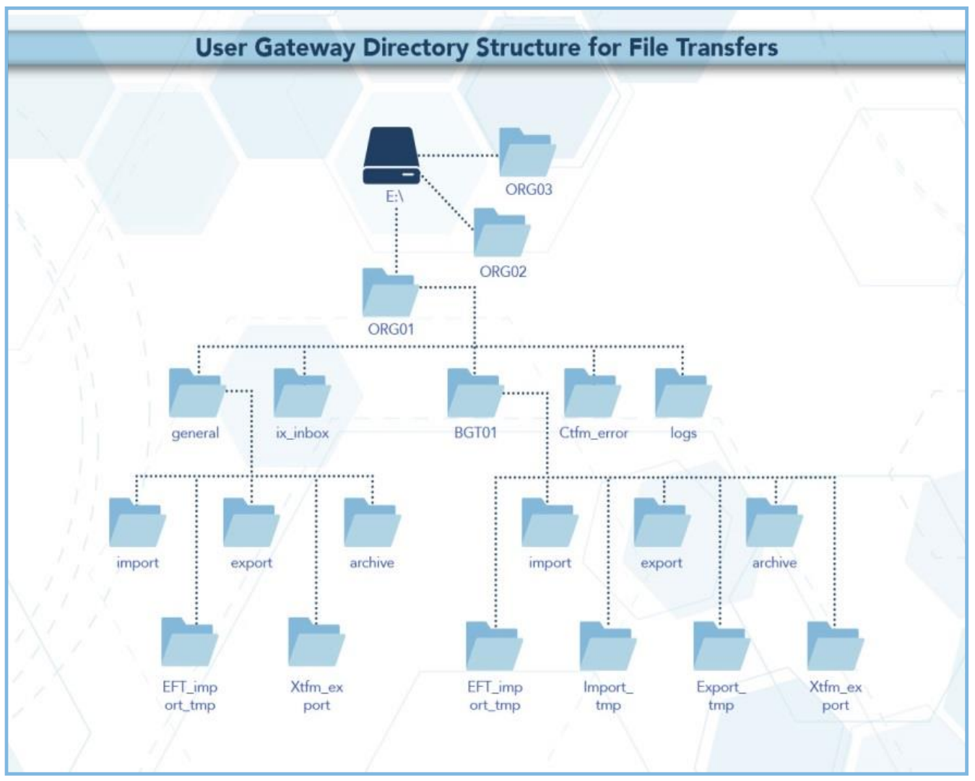

For the avoidance of doubt, it remains the responsibility of the IGT(s) to provide RPC supporting data to Shipper Users by 5pm on the 5th working day following the end of the billing period. The CDSP will endeavour to send on files on the same day on which they are received and, it is recommended that IGT parties provide files ahead of the deadline to allow for any unforeseen circumstance.

Testing

The functionality will be made available in a testing capacity around one month prior to production go live, this will provide customers the opportunity to test the connection to pass Communication Type 2 files. This will not be a formal test phase managed by the CDSP, although support will be provided at a high level. Those customers wishing to participant will be expected to work together to plan any test activities. Further details around the testing approach and timings will be provided as the delivery phase progresses.

Delivery Mechanism / Data Handling

The RPC files will be sent using IX via communication type 2. This is a ‘postbox’ delivery mechanism which is provided by the CDSP to send files between two parties. As part of this communication type, the sender must adhere to the naming convention of 5.8.3 format in order for the file to reach the intended recipient. (See appendix A for further details on naming convention)

The CDSP will not be validating or retaining any information in the files in any way. The CDSP will not have permission to view the content of .RPC files.

Document Update

Within the UKLAD3 UK Link File Transfer Definition document there will be a change in Appendix A under section A5 where it will state;

“Note: RPC files issued by the IGTs will be received by Shippers via import / export
directories in the general directory respectively, consistent with Communication Type 2.”

Handling File Transmission Issues

Where the CDSP identifies issues with the IX and cannot receive or cascade .RPC files, the CDSP will communicate issues to the IGTs and Shippers’ Contract Managers as per business as usual (BAU). This will also be the case in circumstances where IGTs and Shippers need to be informed of their individual IX equipment being down.

In the event of complete file transfer failure, the CDSP will attempt to provide an alternate file delivery
service within 48 hours of the failure.

If UK Link Users have any queries or problems relating to file transfers over IX/EFT, they should contact the CDSP Service Desk on the following numbers:
Telephone from the UK: 0845 600 0506
Telephone from outside the UK: +44 121 623 2858.
Alternatively UK Link Users may log a Service Contact via the Service Desk Portal accessible from the ‘Contact Us’ section of the Xoserve website.

The Disaster Recovery Process may be invoked if a UK Link User experiences a loss of the file
transfer service. This is only applicable to those UK Link Users who have arranged for access to a
secondary User Gateway for the purposes of Disaster Recovery.

Implementation Timeline and Funding
In line with workgroup discussions, it is proposed to deliver the change in line with the industry November 2024, this means the first production use of the process will be in December for the November billing period.

The estimated cost for this change which will be confirmed in a subsequent Business Evaluation Report (BER). The proposer of the modification has proposed a funding split of 50/50% Shipper/IGT. This will be presented at the Change Management Committee (ChMC) in June for discussion and approval alongside the functional design of the change defined within this pack.

Appendix A

Summary of File Naming:

Associated Changes
Associated Change(s) and Title(s): | None

DSG
Target DSG discussion date: | 20/05/2024
Any further information: | None

Implementation
Target Release: | Release: November 2024
Status: | For Approval

Industry Response Detailed Design Review
«RangeStart:HDS»
Change Representation
(To be completed by User and returned for response)
Please consider any commercial impacts to your organisation that Xoserve need to be aware of when formulating your response

User Contact Details: | Organisation: | «h1_organisation»
 | Name: | «h1_name»
 | Email: | «h1_email»
 | Telephone: | «h1_telephone»
Customer decision on Change Pack: | «h1_userDataStatus»
Commercial impacts: | «h1_commercial_impacts»
Representation Publication: | «h1_consultation»
Representation Comments: | «h1_userDataComments»

Xoserve’ s Response
Xoserve Response to Organisations Comments: | «h1_xoserveResponse»

Please send the completed representation response to uklink@xoserve.com

«RangeEnd:HDS»

Change Management Committee Outcome
Change Status: | ☐ Approve | ☐ Reject |  |  | ☐ Defer
Industry Consultation: | ☐ 10 Working Days |  | ☐ 15 Working Days
 | ☐ 20 Working Days |  | ☐ Other [Specify Here]
Date Issued: | Click here to enter a date.
Comms Ref(s):
Number of Responses:
Solution Voting: | ☐ Shipper |  |  | Please select.
 | ☐ National Gas Transmission |  |  | Please select.
 | ☐ Distribution Network Operator |  |  | Please select.
 | ☐ IGT |  |  | Please select.
Meeting Date: | Click here to enter a date.
Release Date: | Release: Feb / Jun / Nov XX or Adhoc DD/MM/YYYY or NA

Please send the completed representation response to uklink@xoserve.com

Version Control

Document
Version | Status | Date | Author(s) | Remarks

Template
Version | Status | Date | Author(s) | Remarks | Approved By
1.0 | Approved | 09/03/2022 | Rachel Taggart | Detail Design Change Pack transferred to own document | Change Management Committee on 09/03/2022
1.1 | Approved | 25/04/2023 | Rachel Taggart | Updated with new font branding | Emma Smith
1.2 | Updated | 14/08/2023 | Kate Lancaster | Updated with Representation tabs

