Detailed Design Change Pack

Communication Detail
Comm Reference: | 3383.2 - VO - PO
Comm Title: | XRN 5564 – Enhancement of the Energy Balancing Adjustment Process
Comm Date: | 13/06/2025

Change Representation
Action Required: | For Information
Close Out Date: | 30/06/2025

Change Detail
Xoserve Reference Number: | XRN 5564
Change Class: | Functional
*ChMC Constituency Impacted: | National Gas Transmission / Shippers
Change Owner: | uklink@xoserve.com
Background and Context: | This Change Pack outlines the design details, background, and proposed solution to enhance the Energy Balancing adjustment process.  As part of the Gemini Sustain Plus backlog, a requirement was identified to improve the adjustment process impacting Unique Sites (LDZ/NTS), Biomethane, Input Meters, Interconnector and Trades.  The primary objective of this enhancement is to streamline and accelerate the invoice adjustment process. By introducing a more efficient and transparent workflow, the solution aims to:  - Reduce reliance on email communications.  - Enable Shippers to directly add, review, approve, and reject adjustments for the specified site types.  - Improve visibility and traceability of adjustments across all stakeholders.  Impacted stakeholders and systems are:  - National Gas Transmission  - Shippers

Change Impact Assessment Dashboard
Functional: | Functional changes to Gemini to improve the Energy Balancing Adjustment Process
Non-Functional: | n/a
Application: | Gemini Only
User(s): | n/a
Documentation: | n/a
Other: | None

There are no File changes that are part of this Change Pack.
File | Parent Record | Record | Data Attribute | Hierarchy or Format  Agreed
n/a | n/a | n/a | n/a | n/a

Change Design Description
The solution will include the below changes to the Gemini System.

- Allocation Service:

- New online screen to add/update post closeout energy adjustments. The below subsequent points cover the functionality to support the new online screens

- Online Screen Functionality:

- The Gemini System will have the new screen ‘Post Closeout Energy Adjustment’ and will be available in the below menu path ‘Home > Allocations > Post Closeout Adjustments > Post Closeout Energy Adjustment‘

The Screen will facilitate:

- Shippers will have the ability to add revised adjustments for each of the following Site Types

US - Unique Site (Allocated by National Gas Transmission)
OS - Onshore Field
DC - Daily Metered Consumer
DF - Daily Metered Aggregate Firm
NB - National Balancing Point

- National Gas Transmission and Correla Billing Team Users will be given the ability to query/add/approve/reject/export report the revised adjustments submitted by the Shippers

- The new ‘Post Closeout Energy Adjustment’ screen will have the below listed functionalities

- Onload
- Run Query
- Add Functionality
- Export Report Functionality

- Confirm Functionality:

- Shippers will be able to access the Confirm button

- Confirm button will be enabled only for records that are in Amended status

- On Click of Confirm, system will move the status to “Confirmed” and send notification to National Gas Transmission and Correla Billing Team Users

- Raise Dispute Functionality:

- Shippers will be able to access the Raise Dispute button

- Raise Dispute will be enabled for records that are in Amended Status

- On Click of Raise Dispute, system will open a new pop-up and allow the Shippers to enter the comments and upload attachments for the allocation-adjustments that are in amended status, along with the following action buttons – Save and Cancel

- On Click of Save, system will update the comments added and move the status to “Disputed” against the record inside the existing table

- On Click of Cancel the System will navigate back to the details page

- The below table lists the functions that will be available to the Shippers based on the Meter Type

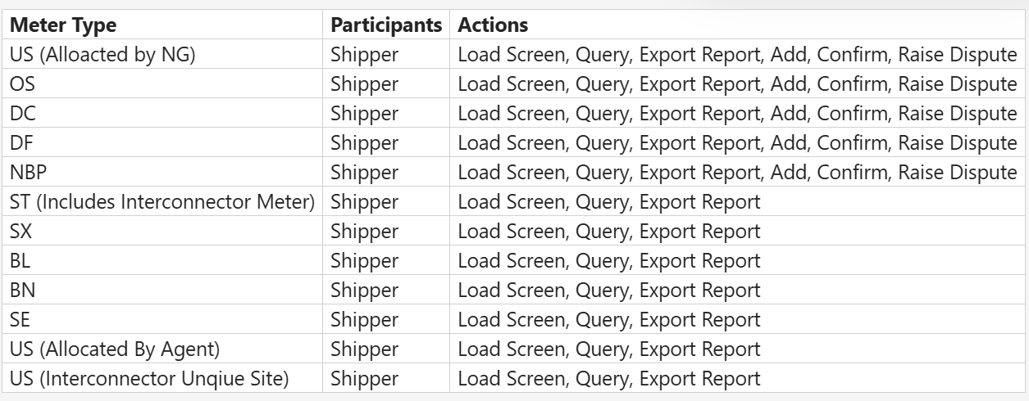

- Due to the relatively minor size and scale of the changes being made, Market Trials is not going to be offered however new training material will be created. This will be incorporated into the existing Gemini Learning Management System

- Notification Email Templates - The embedded file (below) shows the email templates that could be received by the Shippers depending on the action performed

Associated Changes
Associated Change(s) and Title(s): | n/a

DSG
Target DSG discussion date: | n/a
Any further information: | n/a

Implementation
Target Release: | Adhoc release September 2025
Status: | For Approval

Industry Response Detailed Design Review
«RangeStart:HDS»
Change Representation
(To be completed by User and returned for response)
Please consider any commercial impacts to your organisation that Xoserve need to be aware of when formulating your response

User Contact Details: | Organisation: | «h1_organisation»
 | Name: | «h1_name»
 | Email: | «h1_email»
 | Telephone: | «h1_telephone»
Customer decision on Change Pack: | «h1_userDataStatus»
Commercial impacts: | «h1_commercial_impacts»
Representation Publication: | «h1_consultation»
Representation Comments: | «h1_userDataComments»

Xoserve’ s Response
Xoserve Response to Organisations Comments: | «h1_xoserveResponse»

Please send the completed representation response to uklink@xoserve.com

«RangeEnd:HDS»

Change Management Committee Outcome
Change Status: | ☐ Approve | ☐ Reject |  | ☐ Defer
Number of Responses:
Solution Voting: | ☐ Shipper |  | Please select.
 | ☐ National Gas Transmission |  | Please select.
 | ☐ Distribution Network Operator |  | Please select.
 | ☐ IGT |  | Please select.
Meeting Date: | Click here to enter a date.
Release Date: | Release: Feb / Jun / Nov XX or Adhoc DD/MM/YYYY or NA

Please send the completed representation response to uklink@xoserve.com

Version Control

Document

Version | Status | Date | Author(s) | Remarks
1.0 | For Approval | 13/06/2025 | Correla

