Detailed Design Change Pack

Communication Detail
Comm Reference: | 3342.3 - VO - PO
Comm Title: | XRN5564 - Gemini Sustain Plus Programme (Including Screen Detail)
Comm Date: | 17/02/2025

Change Representation
Action Required: | For Information
Close Out Date: | 03/03/2025

Change Detail
Xoserve Reference Number: | XRN5564
Change Class: | Functional
*ChMC Constituency Impacted: | National Gas Transmission, Shippers, DNOs, Traders
Change Owner: | Simon Harris  Service Manager (Gemini Services)  Geminiengagement@correla.com
Background and Context: | The purpose of this Change Pack is to provide the industry with additional information regarding enhancements that will be implemented in March 2025 in line with the original scope of the Gemini Sustain Plus Programme and to also capture additional functional changes that have been incorporated since October 2024.  The first version of this Change Pack was approved in February 2024, and a subsequent version was approved in October 2024 which included additional detail and examples of the changes to the on-line screens.  Changes made to on-line screens are viewable in the training package (the Learning Management System) which is referenced in section 15.  The Gemini Sustain Plus Programme will deliver the technology transformation of sustaining the Gemini platform by modernising and updating current legacy components into a modern, cost efficient and scalable solution that reduces operating costs and the ongoing cost of change.  The key benefits of this change are:  • Improve business capability and the user/ customer experience (e.g. extending the Gemini System to 24 hours availability).  • Achieve improved efficiency through reduced operating costs.  • Increase flexibility to accommodate increasing pace of Regulatory Change.  Customer Focus Group sessions will continue allowing all Gemini Users the opportunity to understand Programme progress, exposure to system demonstrations of newly tested processes and areas of functionality pertinent to them. This will help with familiarisation of the updated interface ahead of Go Live and will also provide the opportunity for customers to ensure that they can connect and log in to the System in preparation for Day One.  If you would like to register for future sessions, please contact Geminiengagement@correla.com  All material shared during these sessions along with FAQs will be made available on the programme website; Gemini Sustain Plus (xoserve.com)  The Change Description section below provides detail on the structure of the upgraded system and highlights the key differences from the Legacy platform.

Change Impact Assessment Dashboard
Functional: | The modernisation of the Gemini platform has resulted in a multitude of changes that has impacted the various parts of the application. Users of the system will mainly notice the look of each User Interface (UI) layer and every screen has changed along with some of the functionality. Unless specifically identified in the sections, the below functionality has remained the same as the legacy system.  Whilst there are cosmetic changes to all screens and to some functionality, there will be no change to file flow or existing API definitions.  To support and prepare Users this Change Pack has been produced to share detail on relevant screens for the changes listed below.  The enhancements and functionality changes are grouped into the following Gemini process areas below:  - Capacity processes  Auction Calendar Dashboard Enhancement - The Auction Calendar Dashboard is being enhanced as follows:  - Will display the Auction Type data in ascending order.  - The information for each Auction Type will include the Sold/Unsold Capacity for that Method of Sale (MoS).  - The facility to extract the auction information in Excel format.  - The ability to select a Live auction and be taken directly to the relevant screen to place bids.  Please see Screen shot 17 in Appendix C for the screen shots relating to this process.  Offtake Capacity Statement (OCS) Enhancement - For the Gemini OCS and Offtake Pressure Statement (OPS) process the bulk upload facility is being enhanced to include a predefined template that can be downloaded in order to be populated by the DN user and uploaded.  Example of the OCS and OPS Request File:  Define location enhancement (unification of Entry and Exit)  As part of the process of combining entry and exit into a unified system it has been highlighted that the Define Location screen, will now include visibility entry sites as well as only exit sites.  - Energy Balancing Processes  Over the Counter (OTC) Enhancement - For OTC, once a shipper has placed a trade nomination, an automatic email notification will be triggered to the counter party * which will look as follows:  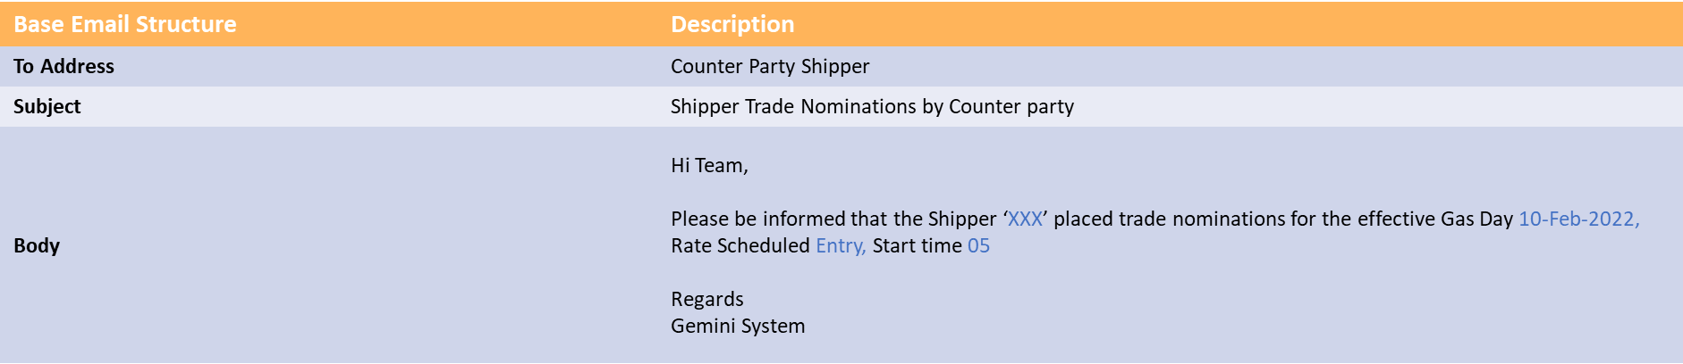  *Unless no specific email address has been provided for the OTC counter party notification.  Storage Exit Meter process enhancements – For Storage Exit Meter IDs created either by Batch process or Online Screen, a new Batch job is automatically triggered for the Activity number creation for the respective Meter IDs. – screen shot not available as this is a batch job  Unique Site Energy Enhancement - There will be enhancements to the Unique Site Energy Query screen with the addition of an “upload” button that will allow Agents to upload the Unique Site Energy data at Site Level and Meter Level into Gemini Screen whenever Energy is Modified.  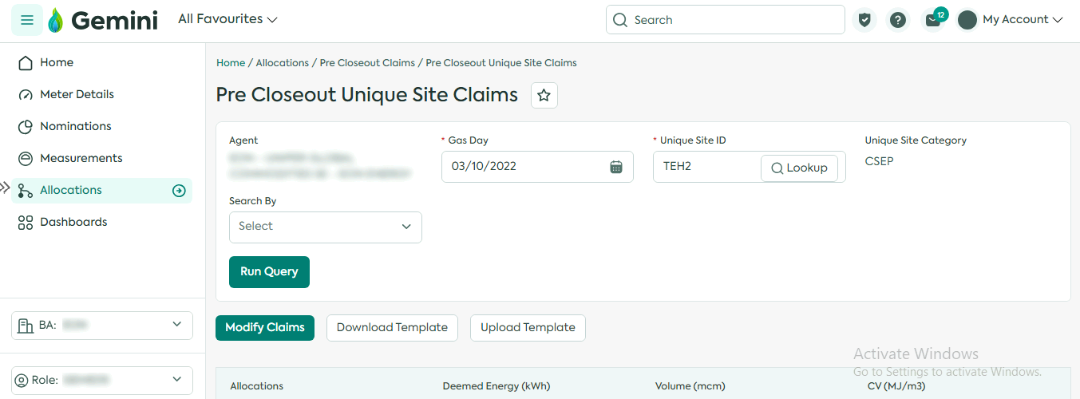  New Nomination and Allocation screen – A new screen will be added to be able to view Nomination, Trade and Allocation data at an aggregate level which can be drilled down further to meter type and meter ID level information and be able to download a report.  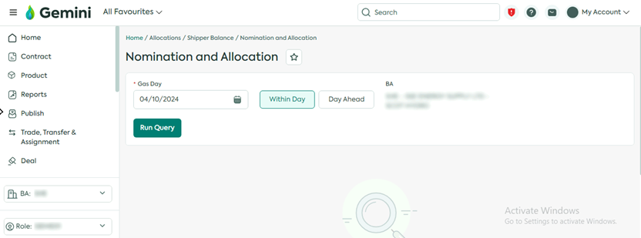  Example of the Nomination and Allocation Report:  Live Capacity vs Nomination Report Screen Enhancement  When UNC Modification 785 was implemented the ‘Live Capacity vs Nomination’ report showed BACTONINT and BACTONBBL as the Requested Nomination (kWh/d) and Confirmed Nomination (kWh/d) values and the BACTONEXITIP which shows the Net Entitlement details on separate rows.  The screen has been enhanced to display only BACTONEXITIP, which for the Requested Nomination (kWh/d) and Confirmed Nomination (kwh/d) values is a total of the BACTONINT and BACTONBBL values which gives a more reflective picture of the Utilisation % on the screen.  A new ‘for information’ note is also added onto the screen to state that this is included in each of the values.  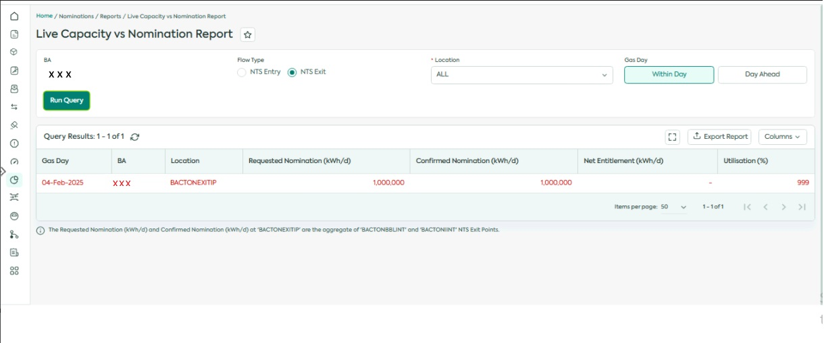  - Constraint Management  Constraint Management Enhancement - In the event of a Constraint on the network an additional notification will appear as a pop up or “Toaster” message to any user logged into Gemini at the time. Please see screen shot 52 in Appendix C for screenshot of the enhancement.  - Invoicing  Shipper Indebtedness report Enhancement - The “View and Print Cash Call Report” Screen will be enhanced to provide the access to the shippers to run and view their own indebtedness report.  Example of the Indebtedness Report:  - TSO only Energy Balancing enhancement – For information only  TSO Nomination Enhancement - An Excel Report will be generated which contains Nominated (Requested) v/s Confirmed (Scheduled) EU Nomination Data (Requested Energy is not equal to Scheduled Energy). Nomination matching at IP enhancements for Gas Day D-1, D and D+1. This report will be sent to the Transmission System Operators (TSOs) via e-mail*. An example of the email is as follows:  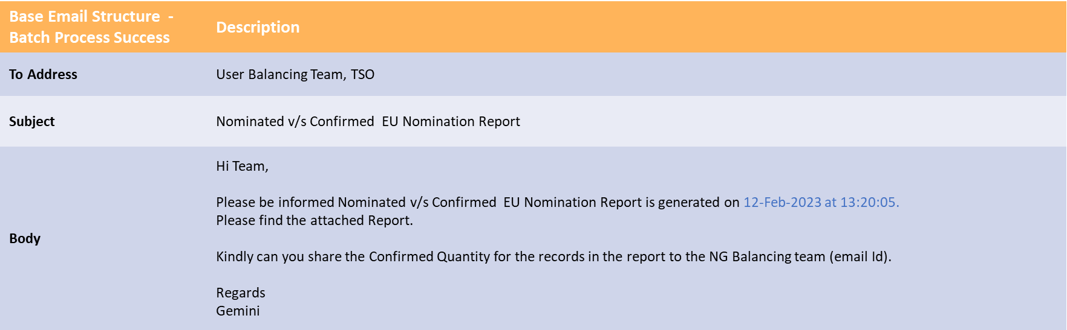  * Unless no specific email address has been provided for the EU nomination report.  - Additional functional changes that impact the whole of the Gemini platform  Service Now Enhancement - Service Now integration will be available in the Gemini platform to ease the customer journey when raising an issue or request without having to close their current session or use another tab to raise a ticket.  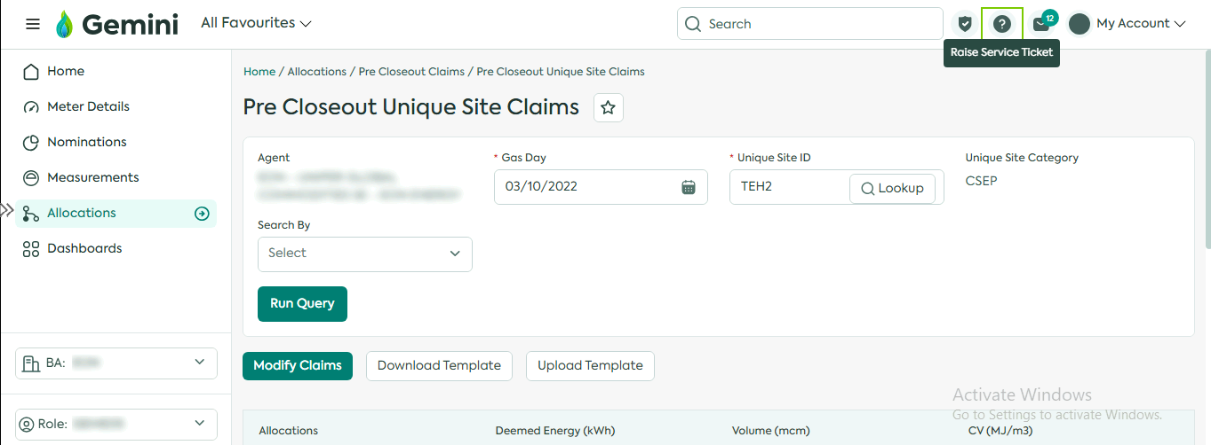  Gemini Data retention - To keep the data needs of Gemini in line with the UNC obligations it will retain transactional data for 10 years with the exception of auction data which will be retained for 20 years. This meets the industry UNC requirement with 3 additional years if customers require it. Once data has exceeded the agreed retention periods then it will be periodically purged from the system.  Gemini Reports Enhancement - The modernisation of Gemini will allow Users to generate and view reports in the system relating to their user role all within one screen.(e.g. capacity and revenue by bid report).
Non-Functional: | Non-functional enhancements that are being delivered with the Gemini Sustain Plus Programme:  - Non-Functional enhancements  Gemini Bi-annual Clock Change Enhancement - The bi-annual Gemini clock change activity will now be automated in Gemini via the system automatic settings and will change in line with the UK clock change. Thus, removing the impact on the whole industry to implement the change with an outage.  Gemini Architecture Enhancement - The type of architecture used provide the ability to remove the regular maintenance window leading to Gemini having 24-hour, 7 day availability. This will allow all Gemini Users access to the system at any time.  Gemini System Unification - Gemini and Gemini Exit are being brought together as a single application enabling the User to navigate more easily between the various processes and screens.  Gemini User Interface (UI) Enhancement - The Gemini UI will provide a new look and feel as well as additional functionality that will enhance the User experience. A full list of the common components and features can be found in Appendix B, screen shots can be found in Appendix C. For demonstrations of the updated Gemini UI please see the Previous Sessions of the Focus Group on Gemini Sustain Plus (xoserve.com). Examples of the upgraded Gemini UI will also be available on our Learning Management System in the “Gemini Basic Navigation” e-module that will be accessible for all Gemini Users.  Gemini Accessibility Enhancement - All Users will be able to access the Gemini platform application via any device that has a standard modern web browser, although the screens are optimised for a regular sized web browser window.  Gemini Inactivity change – In order to enhance security the Gemini system will automatically timeout and the User must log in again after a set period of time. This was originally set as 15 minutes based on feedback from Users during Market Trials this will now be set to 60 minutes and will be included in the UK Link manual.  To understand the current legacy position of these change vs the new enhancements please see Appendix A.
Application: | Gemini
User(s): | All Gemini system Users including shippers, agents and DNs.
Documentation: | None (UK Link Manual updates to be done via separate Change Pack)
Other: | None

Files
File | Parent Record | Record | Data Attribute | Hierarchy or Format  Agreed
NA | N/A | N/A | N/A | N/A

Change Design Description
- Solution Overview

The Gemini Sustain Plus programme will modernise and enhance the current Gemini system, moving to a public cloud, microservice and PaaS based solution. This approach will allow a more agile approach to delivering and managing change, reduce operational overheads and improve the security, scalability and availability of the system.
The diagram below highlights key endpoints of the Gemini platform that will be affected by this change. Building on previous system enhancements that made access to Gemini APIs and Screens more readily accessible over the internet this will now become the only access method available (IX based access to APIs and Screens will cease).

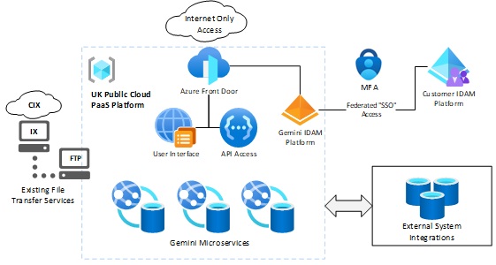
This will be enhanced by introducing a federated SSO approach that allows customers to use their own organisation login credentials to access Gemini with MFA being enforced using either an authenticator app or an Email\SMS one time code.

The deployment of a Microservice Design on a public cloud PaaS platform enhances the level of availably that can be supported allowing Gemini to no longer require a regular maintenance outage and be available 24/7 as well introducing enhanced security and disaster recover capability making the solution more robust and reliable.

- UI / UX Framework / System Design

We will be making amendments to all screens within the Gemini system and part of best practices we have created a framework which each of the screens and buttons will follow to ensure consistency across the application.

Examples of this will be shared in the later change pack for information along with the system screens.
10. API Access

As part of the delivery of the Gemini Sustain Plus programme, connectivity to APIs will use internet-based access and will enforce oAuth2 based authentication mechanism using JWT (this ensures a more robust security framework is enforced than was previously supported via IX based access) – the login process is shown below.
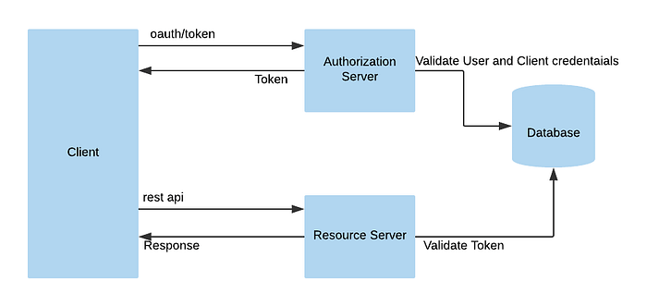
Credentials will be provided to customers through the Gemini ServiceDesk and resets to credentials as well as provisioning of new accounts will follow the same procedures as are currently in place (i.e. LSO or nominated contacts will be required to raise requests with the Gemini ServiceDesk).

The API platform builds on the previously introduced API gateway (introduced as part of GSE) and will continue to support XML based queries while also supporting JSON based API queries in line with most modern API platforms using a RESTful API interface model.
As is currently the case, connectivity will be via an API client that is managed by the organisation accessing Gemini. Current API functional specifications will remain the same, these specifications will continue to be published and made available to Gemini System Users via the Xoserve website.
- Screen Access

As part of the delivery of the Gemini Sustain Plus programme, access to Gemini screens will only be available via internet based connectivity and will no longer require the use of Citrix. End users will be able to connect directly to the web application from any location using any modern web browser - This will simplify connectivity and support access from any internet connected location used by the connecting organisation.

As previously mentioned – end users will be able to log into the Gemini screens using their organisations login ID rather than being given a separate set of credentials specifically for Gemini as is currently the case.

This approach means that end users will be able to resolve any password related issues via their own internal support processes rather than being dependant on the Gemini service desk and it will provide a more modern and simple SSO experience.

The below diagram shown a simplified overview of the user login experience and steps.

  - 12. IP and Domain Details

Access to the Gemini APIs and Screens endpoints will use a new URL, this will be simplified form the current configuration where multiple URLs and domains are used and will utilise a common base URL of https://geminiplus.co.uk/ - this URL terminates on the Microsoft Azure Front Door content delivery network which provided enhanced protection against DDoS attacks and other internet based security threats.
The domain details for the new URL will be resolvable via standard public DNS services and the connectivity will utilise standard HTTPS protocol (port 443), this means that connectivity should not require any special configuration on the customers network if standard internet access is readily available.
When specific IP addresses are required to be allowed on the customers network then these IP addresses are managed by Microsoft and published by them – these can be manually accessed by the customer or many modern network appliance and network service providers allow these to be dynamically maintained – further information is available here https://www.microsoft.com/en-us/download/details.aspx?id=56519.

  - 13. User Roles/ User IDs

The unification of Gemini and Gemini Exit has provided the opportunity to combine user roles for ease of use going forwards. The table below lists the current Gemini user roles available to external users with the proposed new user roles listed on the right.

An audit of Gemini user accounts will be undertaken because each Gemini user will require a new log in that uses their organisation email address, this will be used as part of the federated access being introduced as part of the Gemini Sustain Plus Programme which is listed further down in this change pack. This will require LSOs to provide details of who in their organisation requires access to the Gemini system. Failure of the LSOs to do this will mean their users will not have access to Gemini in readiness for Go Live. The legacy Gemini system will no longer be available post go live, and there will be no parallel running. Historic data will be transferred to the system.

It is important that all customers take the opportunity to undertake connectivity testing, onboarding, Market Trials and training to ensure they have the correct access to ensure smooth transition for go live.

The following table is the proposed Gemini Roles:
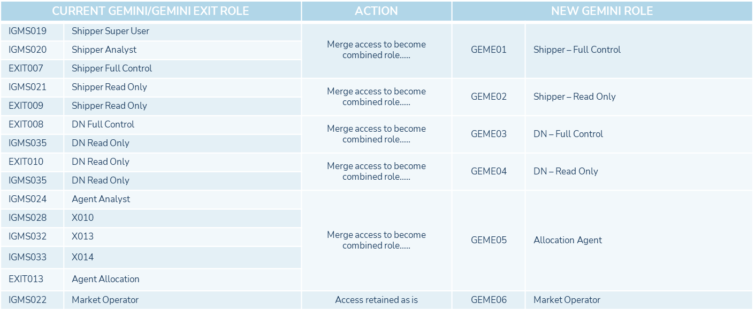

  - 14. Connectivity, Onboarding and Market Trials

As part of the programme we will be running a period of Connectivity, onboarding and Market Trials in Q2 2024 to ready the industry for the implementation of the new Gemini application.

The connectivity and onboarding phases will provide a period in which the programme will be supporting the industry to connect to both the Gemini Market Trials environment and to be production environment as well to onboard both individual & API users. Successful completion of these activities will ensure that organisation will have the connectivity and set up required for them to access the upgraded Gemini Platform come Go-live.

The Market Trials phase which will follow connectivity and onboarding, will allow successfully connected and onboarded Gemini Users to access and familiarise themselves with the new Gemini UI and be able to undertake a select number of key processes using dummy data.

Further detailed communication will follow in Gemini Sustain Plus Focus Group, Industry Forums and communications.

  - 15. Training

The existing e-learning currently available on the Xoserve website for Gemini will be replaced by a Learning Management System (LMS). The new LMS will house e-modules that will cover the various Gemini processes that are undertaken by the industry in their own training domain.

The LMS provides a user-friendly interface to allow for self-learning for users to understand background and undertake the Gemini processes relevant to their roles as well as processes that may be outside of their role but within their market segment i.e., Shipper, DN, Agent etc. The LMS also provides the user and organisations, via a super user, the ability to track and report on progress of the e-modules. Access to the new LMS has been shared in January 2025.

  - 16. File Interfaces

For most organisations that use Gemini, file interfaces use the IX solution which provides an FTP mechanism for sending and receiving files from Gemini as well as other organisations and systems such as UK Link.
Any changes to the current IX FTP file transfer solution and processes around this are not in the scope of the Gemini Sustain Plus programme and so there are no details included in this Change Pack.
  - 17. Security Enhancements

The delivery will include security enhancements that will be integrated into the public cloud services being used. These enhancements will strengthen the security posture of the Gemini platform and will remove or mitigate certain areas of technical debt from the existing Gemini platform.

This approach will allow the removal of the Citrix content delivery mechanism that is currently used to support access to Gemini user screens and will also support the introduction of more friendly methods of managing user identities, providing greater flexibility with connectivity options and device compatibility. Some of these enhancements are described in more detail below:

  - 18. Federated Identity

Customers will be able to federate using their own identity provider to access the service. This will give users the ability to use Single Sign on (SSO) from accounts which they use on a day-to-day basis and do not have to maintain another set of credentials which could be stored insecurely. This gives the customer the flexibility to manage identities for Gemini in the same way that they would manage identities for other applications and services that SSO has been configured for within the customers organisation. This will allow password resets, password strength and complexity, account security monitoring and account decommissioning to be managed by the customer who may have compliance requirements they need to adhere to. Authentication shall be enhanced with the introduction mandatory MFA and geolocation filtering through conditional access policies to reduce the risk of compromised accounts accessing the platform. This will then be supported by OAuth 2.0 to manage authorisation to the application. Customers shall be able to support their user identities under their own corporate policies and are responsible for making sure that each account is governed in a way that is appropriate to their security and compliance requirements.

  - 19. Internet Accessibility

It shall be hosted within Azure and be publicly accessible over the internet. Requirements to access via Citrix will no longer be in place.

Web services shall be accessible via Azure Front Door which is enabled with Azure WAF v2 and scans all inbound traffic coming into Front Door using a Microsoft managed ruleset that is based off the OWASP common web application security risks. If the WAF detects that there are malicious payloads submitted through a HTTP request, then it shall block the attack before traffic is routed to any of the microservices. This shall help to prevent common types of attack techniques at the application edge.

The platform operates a defence in depth strategy which accounts for remediating vulnerabilities in the platform discovered through penetration testing and vulnerability scanning. This is to ensure that any attacks that manage to bypass the WAF are unlikely to trigger publicly released vulnerabilities on the backend.

  - 20. Security Monitoring

The new Gemini platform will include a comprehensive set of security monitoring, threat detection and intrusion prevention systems maintained by the system operator. The use of Cloud PaaS services will also help to ensure that the underlying platform is continuously maintained and protected with improved security standards being introduced in relation to access control and authentication of system users and interfaces.

Associated Changes
Associated Change(s) and Title(s): | n/a

DSG
Target DSG discussion date: | n/a
Any further information:

Implementation
Target Release: | The target implementation date of the Gemini Sustain Plus programme is Sunday 23 March 2025. The contingency date being Sunday 06 April 2025 with extended outages required and confirmed at DSC Change Management Committee.  For information.
Status: | Approved

Appendixes

Appendix A – Legacy Gemini current process

Appendix B –Gemini New UI features

Appendix C –Gemini New UI features – Screen shots

Industry Response Detailed Design Review
«RangeStart:HDS»
Change Representation
(To be completed by User and returned for response)
Please consider any commercial impacts to your organisation that Xoserve need to be aware of when formulating your response

User Contact Details: | Organisation: | «h1_organisation»
 | Name: | «h1_name»
 | Email: | «h1_email»
 | Telephone: | «h1_telephone»
Customer decision on Change Pack: | «h1_userDataStatus»
Commercial impacts: | «h1_commercial_impacts»
Representation Publication: | «h1_consultation»
Representation Comments: | «h1_userDataComments»

Xoserve’ s Response
Xoserve Response to Organisations Comments: | «h1_xoserveResponse»

Please send the completed representation response to uklink@xoserve.com

«RangeEnd:HDS»

Change Management Committee Outcome
Change Status: | ☐ Approve | ☐ Reject |  | ☐ Defer
Number of Responses:
Solution Voting: | ☐ Shipper |  | Please select.
 | ☐ National Gas Transmission |  | Please select.
 | ☐ Distribution Network Operator |  | Please select.
 | ☐ IGT |  | Please select.
Meeting Date: | Click here to enter a date.
Release Date: | Release: Feb / Jun / Nov XX or Adhoc DD/MM/YYYY or NA

Please send the completed representation response to uklink@xoserve.com

Version Control

Document
Version | Status | Date | Author(s) | Remarks
0.1 | Draft |  | Correla | Initial walk through with NG and Correla resources
0.2 | Draft |  | Correla | Screen shots added to accompany enhancements for Internal review with NG and Correla
0.5 | Approved |  | Correla | Approved Screen pack that was approved at ChMC October 2024
0.6 | Draft |  | Corrlea | Added the inactivity window and MOD0785
1.0 | Approved |  | Correla | Changes approved

Template
Version | Status | Date | Author(s) | Remarks | Approved By
1.0 | Approved | 09/03/2022 | Rachel Taggart | Detail Design Change Pack transferred to own document | Change Management Committee on 09/03/2022
1.1 | Approved | 25/04/2023 | Rachel Taggart | Updated with new font branding | Emma Smith
1.2 | Updated | 14/08/2023 | Kate Lancaster | Updated with Representation tabs

