Detailed Design Change Pack

Communication Detail
Comm Reference: | 3334.2 – VO – PO
Comm Title: | XRN5781.1 - UNC Modification 872S - Single-sided Nominations for clearing houses of gas exchanges
Comm Date: | 13/01/2025

Change Representation
Action Required: | For Information
Close Out Date: | 27/01/2025

Change Detail
Xoserve Reference Number: | XRN5781.1
Change Class: | Functional
*ChMC Constituency Impacted: | National Gas Transmission and Shippers
Change Owner: | Simon Harris  Service Manager (Gemini Services)  simon.harris@xoserve.com / Geminiengagement@correla.com
Background and Context: | Please note that this change has, as agreed with ChMC, been raised as a ‘child’ change under the umbrella National Gas Regulatory Change XRN5781.  The purpose of this Change Pack is to give Gemini Users visibility of the changes we are making to the Gemini system to fulfil the requirements of UNC Modification 0872S. Please be aware that the changes covered under this Change Pack are to be made in the new Gemini system and not legacy, the implementation date being in line with the Gemini Sustain Programme.  As there are no functional changes required to industry systems or Gemini System Users, this communication is for information only, however if any you have any questions in relation to this Change Pack, please contact the Gemini Team at Geminiengagement@correla.com.  MOD872S creates a change to Gemini that enables eligible Users “Clearing User” to elect to submit Single-sided Trade Nominations. This means that existing methods of Trade Clearing which involve nominating both client side and Clearing User, logging in using customer (User) accounts is superseded. This former method is at greater risk of erroneous entries and requires account data to be shared, the primary driver for MOD872S.  Criteria for eligibility is restricted to a User which is either:  1) A body which is declared by an Order of the Secretary of State to be a Recognised Clearing User or a Recognised Investment Exchange for the purposes of the Financial Services Markets Act 2000, or  2) Lawfully designated by a Recognised Investment Exchange  Hence there will be a small subsection of Users who may elect to become a Clearing User and have the ability to submit Single-sided Trade Nominations.  Eligible Users will have to apply for this additional functionality should they wish to submit Single-sided Trade Nominations via a new off-line process owned by the Customer Life Cycle Team, details of which will be published on the Xoserve website in readiness for go live.

Change Impact Assessment Dashboard
Functional: | A system level change is required for Clearing Users to view and send Single-sided Trade Nominations using the Gemini system without the need to log-on with a separate Shipper account to send matching information.  Clearing Users will be able to create and view Single-sided Trade Nominations using a new Gemini online screen and the introduction of new associated APIs.  Information on the related technical details of the new APIs will be published in the Gemini API Specification document which will be available on the Xoserve website in readiness for Sustain Plus Go-Live date.
Non-Functional: | n/a
Application: | Gemini, APIs
User(s): | All Gemini System Users including Shippers and Clearing Users
Documentation: | n/a
Other: | None

There are no File changes that are part of this Change Pack.
File | Parent Record | Record | Data Attribute | Hierarchy or Format  Agreed
NA | N/A | N/A | N/A | N/A

Change Design Description
- Solution Overview

The changes below will be undertaken in the Gemini System (in line with Gemini Sustain Go-Live) to fulfil the requirements of MOD872S.

- Authorisation Service to allow one-to-many user mapping for Clearing Users to be associated as a User Agent, to more than one User “Other User”.

- New Gemini online screen for a Clearing User to add/update and export the Single-sided Trade Nominations.

- New external APIs for a Clearing User to add/update and view Single-sided Trade Nominations.

Images of the new Gemini Screen supporting the above are provided below.

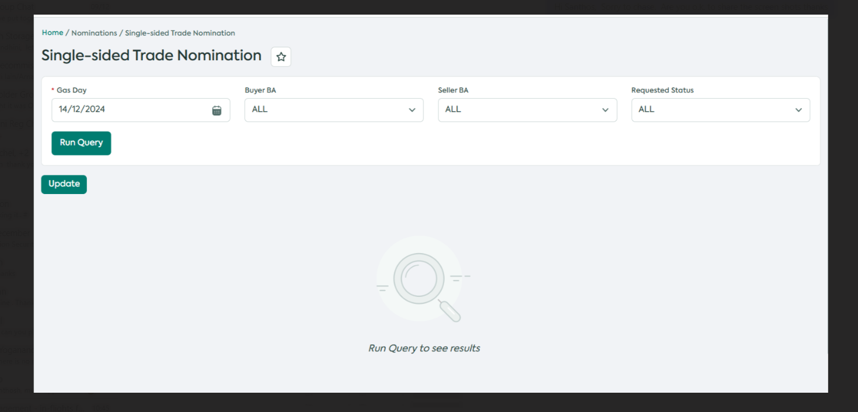

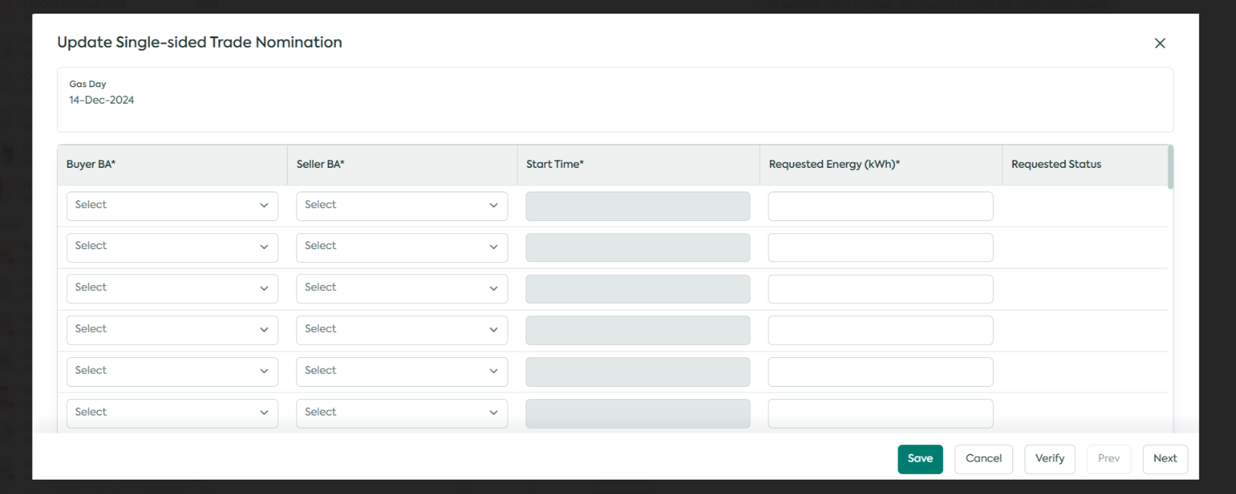

Onboarding Process changes made by the Customer Life Cycle Team / Access Controls:

- Updates to the existing Correla LWIs / application form to onboard a Clearing User to act on behalf of a Shipper.

- User Agreements must be in place for a Clearing User to act on behalf of a Shipper as a User Agent.

- The Clearing User must be either the Buyer or Seller.

- The Clearing User must have a company registration number and be either UK or non UK VAT registered.

- Access Controls setup within Correla is in place to assign a Clearing User a specific Gemini user and API role to add/update and view Gas Trades on behalf of one or more Shippers (given there is a User Agreement in place between the Clearing User and the Shipper(s)).

Associated Changes
Associated Change(s) and Title(s): | XRN5781

DSG
Target DSG discussion date: | n/a
Any further information: | n/a

Implementation
Target Release: | This change is planned to go live in line with the implementation of Gemini Sustain Plus on 23rd March 2025, however a formal Modification Implementation date is pending.
Status: | For information.

Industry Response Detailed Design Review

Change Representation
«RangeStart:HDS»
Change Representation
(To be completed by User and returned for response)
Please consider any commercial impacts to your organisation that Xoserve need to be aware of when formulating your response

User Contact Details: | Organisation: | «h1_organisation»
 | Name: | «h1_name»
 | Email: | «h1_email»
 | Telephone: | «h1_telephone»
Customer decision on Change Pack: | «h1_userDataStatus»
Commercial impacts: | «h1_commercial_impacts»
Representation Publication: | «h1_consultation»
Representation Comments: | «h1_userDataComments»

Xoserve’ s Response
Xoserve Response to Organisations Comments: | «h1_xoserveResponse»

Please send the completed representation response to uklink@xoserve.com

«RangeEnd:HDS»

Change Management Committee Outcome
Change Status: | ☐ Approve | ☐ Reject |  |  | ☐ Defer
Industry Consultation: | ☐ 10 Working Days |  | ☐ 15 Working Days
 | ☐ 20 Working Days |  | ☐ Other [Specify Here]
Date Issued: | Click here to enter a date.
Comms Ref(s):
Number of Responses:
Solution Voting: | ☒ Shipper |  |  | Please select.
 | ☒ National Grid Transmission |  |  | Please select.
 | ☒ Distribution Network Operator |  |  | Please select.
 | ☒ IGT |  |  | Please select.
Meeting Date: | Click here to enter a date.
Release Date: | Release: Feb / Jun / Nov XX or Adhoc DD/MM/YYYY or NA
Please send the completed representation response to uklink@xoserve.com

Version Control

Document

Version | Status | Date | Author(s) | Remarks
0.1 | Draft |  | Correla | Initial walk through with NG and Correla resources
0.2 | Draft |  | Correla | Screen shots added to accompany enhancements for Internal review with NG and Correla

