**Central Switching Service - Bid Group Responsibilities**

1. Purpose
   1. The purpose of this paper is to provide Central Switching Service (CSS) Bid Group (CSSBG) participants with clarification of their responsibilities in relation to Xoserve’s bid to be the CSS Provider to the Data Communications Company (DCC).
2. Background
   1. The CSSBG has been established following Ofgem direction to implement Uniform Network Code (UNC) Modification 0666. It has been convened under the Data Services Contract (DSC), and its members comprise Shippers and Xoserve. Shippers have been required to sign a Confidentiality Agreement. The first meeting of the CSSBG took place on 16th October 2018.
   2. A second UNC Modification (0673) has been raised that proposes amendments to the UNC and DSC to allow Xoserve to bid for and provide the CSS. In order to meet the timescales of the DCC bid process, the Proposer has requested Ofgem direction on the Modification by 30th November 2018.
   3. Following the first meeting of the CSSBG, Xoserve has received feedback from a number of Shippers seeking to clarify their role and the purpose of the CSSBG.
3. Discussion
   1. Modification 666 defines the initial function of Shippers on the CSSBG as assisting Xoserve in developing the bid and advising on (but not participating in) negotiations with the DCC.
   2. Once implemented, Modification Proposal 673 will require Xoserve to seek support from Shippers on the CSSBG for the Contract Budget Risk Range (CBRR); as all other risks will be contained with Xoserve as a limited company.
   3. Xoserve will calculate an upper and lower limit of the CBRR to reflect potential increased charges from Xoserve that Shippers could be exposed to.
   4. The independent assurance partner, PwC will provide a perspective on how well prepared Xoserve is to manage the risks of contracting with the DCC and this will aid Shippers in deciding what of the CBRR to include into their business plans.
   5. For instance, Shippers will be free to assume anywhere from zero to the upper limit of the CBRR and different Shippers may choose different positions.
   6. This CBRR value will be included in the business evaluation report BER for Shipper review and approval. The factors within the CBRR are expressed below in figure 1.

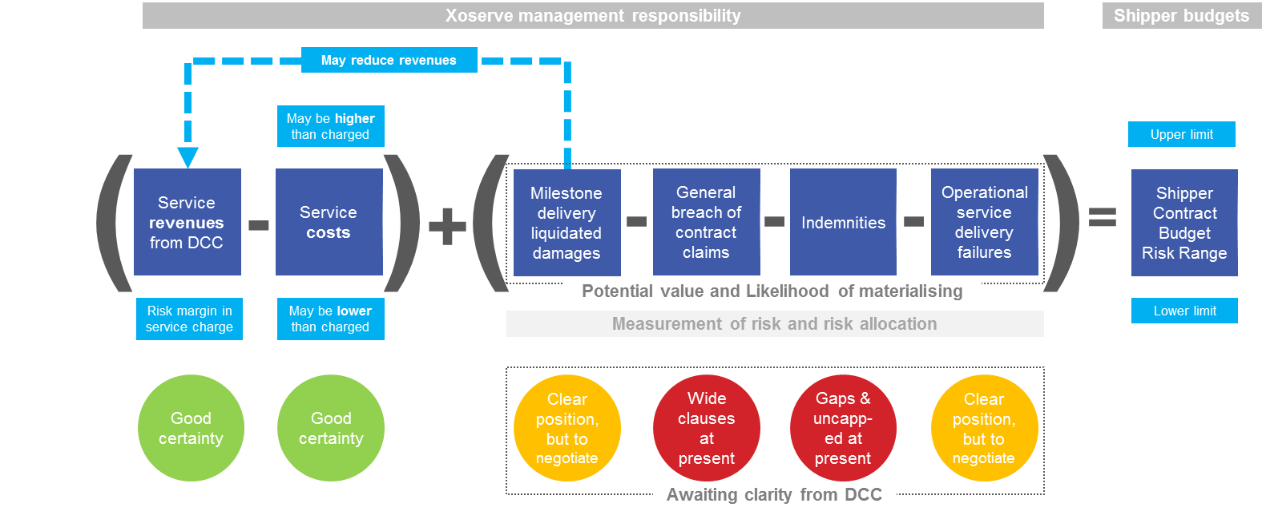

Figure 1

* 1. There are two main aspects that Xoserve will use to calculate the CBRR:
     1. Cash Flow: Shippers are the source of Xoserve’s cash flow requirements to the extent that there is a timing difference between Xoserve’s expenditure and receipt of revenues from the DCC. They also bear a funding risk to the extent that Xoserve’s costs exceed its contractual charges to the DCC, and have the potential for a funding gain to the extent that Xoserve’s costs are less than its contractual charges to the DCC. Xoserve wants Shippers to understand the likely range of financial values and the basis on which Xoserve has prepared its forecasts.
     2. Contract Risk: The DCC contract proposes that there should be four main types of liability – Milestone Delivery Failures; General Contract Liabilities; Indemnities; and Operational Service Delivery Failures. Xoserve wants Shippers to have awareness of the forms of each of these different types of liability, the circumstances under which they might occur, the potential financial values and how Xoserve has included these risks into the CBRR.
  2. Xoserve requires a means by which it can formally capture all of the above and seek CSSBG support prior to entering into contract with the DCC. For this purpose, Xoserve proposes to prepare a Business Evaluation Report as provided for by the DSC Change Management Procedure.
  3. Xoserve has constructed CSSBG agendas to initially share concepts (at the first CSSBG in October 2018), to get a common understanding of terms and responsibilities, and then in subsequent sessions, to share specific content that will be ultimately contained within the Business Evaluation Report. At the second meeting (13th November 2018) Xoserve shared draft cash flow values that will be included in the Business Evaluation Report. Xoserve also shared details regarding the types of liabilities DCC is proposing in the contract, however, Xoserve was unable to share potential liability values due to absence of information with DCC’s draft contract.
  4. Xoserve is seeking greater clarity of the potential liabilities and the period for contract negotiation from DCC. Xoserve ipreparing a Risk Assessment, based on expected values and risk likelihood, which will be utilised for determining the CBRR in the absence of detail from DCC ahead of BAFO submission. This Risk Assessment will be shared in a future CSSBG.
  5. Xoserve will procure the services of an independent assurance provider to carry out a risk-based review and prepare information for both the CSSBG and the Xoserve Board ahead of Xoserve making any final commitment to the DCC. In addition, Xoserve will engage an external legal organisation to review the DCC contract. This assurance will be key in supporting Shippers to decide how much of the CBRR to bake into their business plans.
  6. Xoserve’s management and the Xoserve Board are responsible for committing Xoserve to entry into a contract with DCC, and gain satisfaction of commitments within the bid prior to making such commitment. The Board will also seek confirmation that the CSSBG has given its support to the Business Evaluation Report.
  7. The DCC has set the Best and Final Offer (BAFO) submission date as 21st December 2018. Xoserve is therefore preparing final positions and will present relevant information to CSSBG and the Xoserve Board to gain agreement ahead of submitting Xoserve’s BAFO.
  8. CSSBG meetings have been arranged to review the assurance conclusions, the Business Evaluation Report content and to provide Xoserve with CSSBG’s conclusions.
     1. 10th December 2018 – Assurance conclusions and Business Evaluation Report Walkthrough
     2. 18th December – CSSBG conclusions on Business Evaluation Report
     3. 5pm 21st December – BAFO submission deadline