Detailed Design Change Pack

Communication Detail
Comm Reference: | 3244.3 – VO – PO
Comm Title: | XRN 5690 - Creating a loadable Billing Calendar File for DSC Customers
Comm Date: | 18/12/2023

Change Representation
Action Required: | For representation
Close Out Date: | 02/01/2024

Change Detail
Xoserve Reference Number: | XRN5690
Change Class: | Documentation change
*ChMC Constituency Impacted: | Shippers, DNO, NGT
Change Owner: | uklink@xoserve.com
Background and Context: | DSC customers receive the annual Billing Calendar file from Xoserve via email and, it is also available for customers to download from Xoserve’s website. This file is however in .PDF format and customers then must convert it into a suitable format that can be uploaded into their billing systems. This is deemed an inefficient process as each DSC customer must undertake the same exercise to convert the .PDF file to upload it.  DSC customers have requested that Xoserve provides an ‘operationally efficient’ Billing Calendar e.g. .CSV format that Xoserve can email to customers, at the same time as the .PDF version and, is made available for download from Xoserve’s website.  Change Proposal

Change Impact Assessment Dashboard
Functional: | None
Non-Functional: | None
Application: | Xoserve.com
User(s): | Shippers, DNO, NGT
Documentation: | New Billing Calendar (existing Billing Calendar .PDF format/content unchanged)
Other: | None

File Changes
File | Parent Record | Record | Data Attribute | Hierarchy or Format  Agreed
None | None | None | None | None

Change Design Description
Change Summary
The provision of a .CSV file will reduce the need for each DSC customer to create and sign off the annual Billing Calendar, it will introduce a file that can be uploaded directly into billing systems. A standardised file format is beneficial for those organisations that choose to utilise it.

Rather than replacing the .PDF version that is currently emailed and published on Xoserve’s website, this new loadable .CSV file would be in addition to it. There is no requirement to amend or remove the .PDF version.

The anticipated benefits will arise from the reduction of manual effort required to convert the Billing Calendar file from .PDF into .CSV and, mitigate the requirement for DSC Customers’ internal sign-off prior to uploading the .CSV file into their billing systems.

The CSV billing calendar will be published on Xoserve.com and emailed to Shippers as is currently done with the PDF version.
The first CSV billing calendar will be published as soon as possible, this is likely to be January 2024. Each following year will be published with the PDF and ICS files in December; https://www.xoserve.com/news/2024-billing-calendar/)

For the avoidance of doubt: The billing calendar CSV file will contain all Invoice Types and, the General and Specific Services monthly billing dates.
Service line reference is ASGT-CS-SA10-09. 'How service requirement delivered' will need to be updated.
The CSV will be formatted as below:
- Invoice Type e.g. BAL, CAZ, COM, AMS etc / ‘General’ & ‘Specific’ Service(s)
- Billing Month & Year e.g. APR-22
Formatted as date MMM-YY
- Invoice Date e.g. 20230604
Formatted as date YYYYMMDD
- Payment Due Date e.g.20230420
Formatted as date YYYYMMDD
- Bank Holiday e.g. Christmas, Boxing Day, New Year
Formatted as text and aligning to how they are referenced on Gov.uk
- Bank Holiday Date e.g. 20231225
Formatted as date YYYYMMDD

Change Funding Arrangements:
Due to the size and nature of the proposed change, we do not anticipate any additional funding requirement will be necessary to complete the required work; with activities, including ongoing, future activity, being performed by Service & Operate funded resources.

Example File:
Note: The first entries include all the bank holidays for the year and are not related to the invoice on the same line.
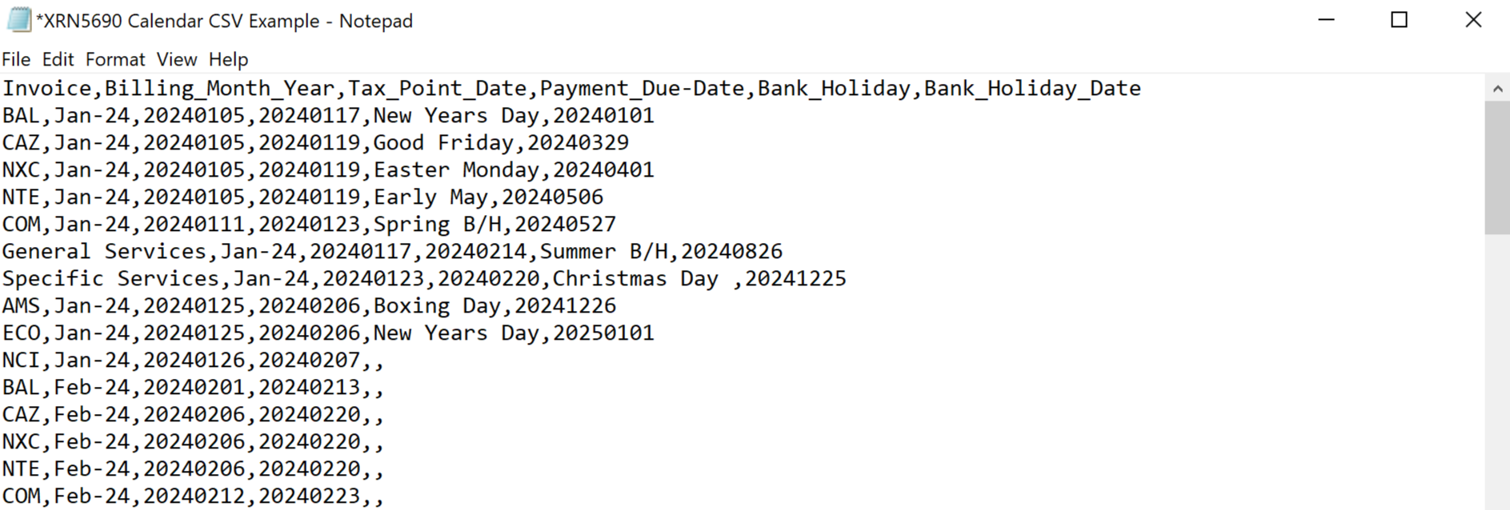

Associated Changes
Associated Change(s) and Title(s): | None

DSG
Target DSG discussion date: | 18/12/2023
Any further information: | To discuss any comments provided from the Detailed Design Change Pack representations.

Implementation
Target Release: | As soon as possible
Status: | For approval

Industry Response Detailed Design Review
«RangeStart:HDS»
Change Representation
(To be completed by User and returned for response)
Please consider any commercial impacts to your organisation that Xoserve need to be aware of when formulating your response

User Contact Details: | Organisation: | «h1_organisation»
 | Name: | «h1_name»
 | Email: | «h1_email»
 | Telephone: | «h1_telephone»
Customer decision on Change Pack: | «h1_userDataStatus»
Commercial impacts: | «h1_commercial_impacts»
Representation Publication: | «h1_consultation»
Representation Comments: | «h1_userDataComments»

Xoserve’ s Response
Xoserve Response to Organisations Comments: | «h1_xoserveResponse»

Please send the completed representation response to uklink@xoserve.com

«RangeEnd:HDS»

Change Management Committee Outcome
Change Status: | ☒ Approve | ☐ Reject |  |  | ☐ Defer
Industry Consultation: | ☒ 10 Working Days |  | ☐ 15 Working Days
 | ☐ 20 Working Days |  | ☐ Other [Specify Here]
Date Issued: | 18/12/2023
Comms Ref(s): | 3244.3 – VO - PO
Number of Responses: | 3
Solution Voting: | ☒ Shipper |  |  | Approve
 | ☐ National Grid Transmission |  |  | Please select.
 | ☐ Distribution Network Operator |  |  | Please select.
 | ☐ IGT |  |  | Please select.
Meeting Date: | 10/01/2024
Release Date: | Adhoc
Please send the completed representation response to uklink@xoserve.com

Version Control

Document
Version | Status | Date | Author(s) | Remarks
V0.1 | Draft | 06/12/2023 | Benjamin Snell | Initial draft
V0.2 | Draft | 08/12/2023 | Benjamin Snell | Stakeholder feedback
V1.0 | For approval | 13/12/2023 | Benjamin Snell

