Section G: Change Pack

G1: Communication Detail
Comm Reference: | 2832 - RT - PO
Comm Title: | Notice of Delivery of Modification 0728B Change
Comm Date: | 28/05/2021

G2: Change Representation
Action Required: | For Representation
Close Out Date: | 07/06/2021

G3: Change Detail
Xoserve Reference Number: | Related to XRN5341
Change Class: | Functional
ChMC Constituency Impacted: | Shippers, NG Transmission
Change Owner: | NG Transmission
Background and Context: | The purpose of this communication is to provide information of the system changes to UKL Gemini and UK Link under UNC0728B, Introduction of Conditional Discount for Avoiding Inefficient Bypass of the NTS with 28km distance cap. On 27th April 2021 OFGEM decided to implement UNC0728B  The revised NTS Charging Methodology (in place from 01 October 2020) does not incorporate a mechanism to dis-incentivise inefficient bypass of the NTS. This change will introduce a new Conditional Discount to the Charging Framework so that a product to manage potential inefficient bypass will be in place as from 01 October 2021.  To support delivery of UNC728B, changes are required to both UKL Gemini and the UK Link System Applications. These changes will become effective in the systems from 01/10/2021.

G4: Change Impact Assessment Dashboard (UK Link)
Functional: | System changes are required to both UKL Gemini and UK Link.  - Supply Point Administration and Registration.  - New record types and amended records  - New Annual Eligibility file and record types  - UKL Gemini new NTS Optional Capacity Invoice (.NCI) and file formats  - New Charge Type Codes within the following Invoices below:  a NTS Optional Capacity Invoice (.NCI)  b NTS Entry Commodity (.ECO)  - Additional reason codes to existing NTS Entry Capacity (.NTE) invoice
Non-Functional: | Transaction Volume, Data Volume, Performance,
Application: | SAP ISU, SAP BW, AMT, PO, UKL Gemini
User(s): | Shipper, NTS
Documentation: | N/A
Other: | N/A

Files
File | Parent Record | Record | Data Attribute | Hierarchy or Format  Agreed
NCI | F00 | N/A | RT_F00_NTS_OPTIONAL_CAPACITY_INVOICE | For Approval
NCI | F01 | N/A | RT_F01_STANDARD_CLAUSE | For Approval
NCI | F02 | N/A | RT_F02_INVOICE_ITEM_SUMMARY | For Approval
NCI | F03 | N/A | RT_F03_TS_ENTRY_CREDIT_RECORD | For Approval
NCI | F04 | N/A | RT_F04_TS_ENTRY_DISCOUNT_RECORD | For Approval
NCI | F05 | N/A | RT_F05_TS_ENTRY_ADJ_CREDIT_RECORD | For Approval
NCI | F06 | N/A | RT_F06_TS_ENTRY_ADJ_DISCOUNT_RECORD | For Approval
NCI | F07 | N/A | RT_F07_TS_EXIT_CREDIT_RECORD | For Approval
NCI | F08 | N/A | RT_F08_TS_EXIT_DISCOUNT_RECORD | For Approval
NCI | F09 | N/A | RT_F09_TS_EXIT_ADJ_CREDIT_RECORD | For Approval
NCI | F10 | N/A | RT_F10_TS_EXIT_ADJ_DISCOUNT_RECORD | For Approval
ECO | G10 | N/A | RT_G10_NTS_GNTS_ADJUSTMENT_RECORD | For Approval
ECO | G11 | N/A | RT_G11_NTS_GNTS_ADJUSTMENT_SUPPORTING_DOCUMENTATION | For Approval
NTE | N10 | N/A | RT_N10_REV_SHARE_ADJUSTMENT_RECORD | For Approval
NMRNRF SNR CFR  CRF SCR  OCI  TNI  TSF  TSR  TRF  TRS  NAE  CRS | U68 | N/A | RT_U68_Discount_Percentage | For Approval
NMRNRF SNR CFR  CRF SCR  OCI  TNI  TSF  TSR  TRS  TRF  CRS | U71 | N/A | RT_U71_NTS OPTIONAL RATE | For Approval
NAE | U67 | N/A | RT_U67_NFTN_ANNUAL_ELIGABILITY | For Approval
NAE | U68 | N/A | RT_U68_Discount_Percentage | For Approval

G5: Change Design Description
An overview of the UNC0728B proposal that is to be implemented is given below.

A new Invoice and new charge types are being created to align with the required charges as proposed under UNC0728B.

New record types are being created and updated to enable System Users to register to apply for the new product on the NTS Exit Point by providing the route details of the Specified Entry Point (Input terminal) and the Specified Exit Point (NTS Exit Point MPRN) they wish to apply for.

New interface files between UKL Gemini and UK Link are being created to align with the requirements as proposed under UNC0728B.

https://www.gasgovernance.co.uk/0728

Overview of the Proposed Solution

A new charging arrangement is proposed specifically for directly connected NTS Users located at, or near, Entry Points where construction of a pipeline to bypass the NTS may be a commercially viable option

The Conditional Product is informed by the costs and benefits associated with remaining connected to the NTS. These criteria and the formula for calculating the product rates will be reviewed periodically, to ensure its suitability and application. This will include the relevance of the product as part of the overall Charging Methodology including, and not limited to, the levels of cross subsidy delivered from the uptake of the conditional arrangement.

The curve used to calculate the discount is an inverse exponential, starting at 90%, the calculated discount without any limitation would run to 0% eventually, but it is proposed to limit the discount to 10%. Below this point (i.e. less than 10% discount), a larger discount is available via the regular interruptible auction and so all Users could find equal or better value outside of the offered bypass avoidance product. It is assumed that the most economic decision would be made by the relevant party to access the lower priced capacity. This therefore informs a ‘cut-off’ for the distance over which this product is available

A distance of 28km is appropriate as it represents a distance which may reasonably result in the construction of a bypass pipeline.

Impacts of UNC0728B to System Users:
As a result of UNC0728B there are some systems changes to UKL Gemini and UK Link:
- New Invoice generated from UKL Gemini
- New Charge Types are being created because of the required charging products in line with the Modification
- New File Formats for SPA and the .NCI UKL Gemini invoice

Design Description:

New Charge Codes:

New charge codes will be added into UKL Gemini and UK Link with corresponding new record types in the new Invoice file format for the UKL Gemini Pass Through Invoices detailed below:

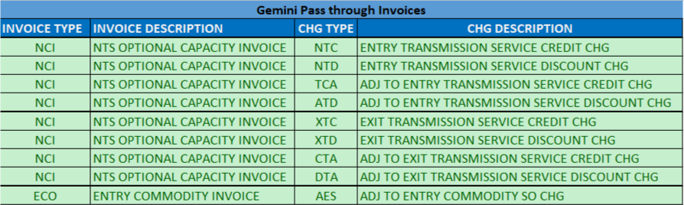

The Comprehensive Invoices Charge Types list for System Users and Transmission are updated below:
015,016
The New Charge Types will also be reflected in the Transmission RTB Template only. There is no impact to DN RTB templates for this change.

Product Application:

To apply for the new NTS Optional Capacity discount produce on an NTS site, System Users will follow the existing SPA Registration Nomination and Confirmation processes.

The existing RT_U70_NTS_OPTINAL RATE record can be submitted as part of the Nomination (.NOM) process for the System User or a Supply Point Amendment (.SPC) can also be submitted using the existing RT_U80_NTS_Optional_Rate_Change.

For Shared Supply Meter Points, the existing RT_U86_SSMP_SHP_NOMTN_DET within the (.SNO) template. The Supply Point Amendment (.SPC) can also be submitted independently by each Sharing User as detailed above.

For the Interconnector sites the existing Interconnector Confirmation Request File (.RCI) or the Interconnector Tariff Switch Request File (.TSI) can be submitted.

The records detailed above allow the System User to provide the Specified Entry Point (Input terminal) and the Specified Exit Point (NTS Exit Point MPRN) they wish to apply for.

The above detailed processes apply the existing timescales as set out in UNC.

Please be advised that in order to enable System Users to submit the requests for a Confirmation Effective date of 1st October 2021, the submission of the above files will be accepted from 7th September 2021 date only in UKLink. If you submit the request before this time the requests will be rejected.

A new record is required to be added to the existing SPA Registration response files and a description amendment to the existing U71 record detailed below. The amended record types are detailed below, and the file formats are embedded:
  - New record Type: RT_U68_Discount_Percentage

  - Amended Description in the existing record type:
    - RT_U71_NTS Optional rate
    - Field: NTS_OPTIONAL_RATE - Rate to be applied will be populated with a zero value as this charge is no longer applicable
U68 / U71:
018,019

SPA Registration Response Files: Hierarchy Document:

001,002,004,005,007,012

SSMP File Formats, Template & Hierarchy Document:

008,008a,008b,009,009a,009b,010,010a,010b

Interconnector File Formats, Template & Hierarchy Document:

006,006a,006b,011,011a,011b,013,013a,013b,014,014a,014b
New SPA rejection codes have been introduced as part of the validation of sites being eligible for the product. Details below:
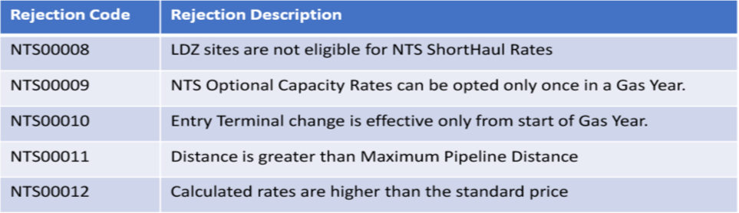

Attached is the updated Shipper rejection document detailing the new rejection code and the affected files:
020
As part of this new product, NGT will be reviewing the sites each year to see which sites are eligible for the product. A new file will be introduced to notify System Users who have taken up the product of the site eligibility. Where the site is no longer eligible they will be removed from the product from the start of the next gas year. The new file and record types are detailed below:
- NAE - Annual Eligible Notification File
    - RT_U67_ NFTN_ANNUAL_ELIGABILITY
    - RT_U68_Discount_Percentage

003, 017,018
For the rules on Eligibility that are applicable to applying for the new product please refer to the Modification documentation as available via the link at the beginning of this section.

Invoice File Format:

There is no impact to the UKLink Commodity Invoice (.COM) or the Amendment Invoice (AMS) as these relate to General Non Transmission Services charges only and the new Charge Types for this product will be processed via the UKL Gemini Pass through Invoices detailed below:
To apply the Discounted rate a new NTS Optional Capacity Invoice (.NCI) is being introduced.

This invoice will be issued on M+19 and any amounts payable by Users to the Transporter and by the Transporter to Users in accordance with the Uniform Network Code will be invoiced and payable in accordance with Section S. Invoice file extension is .NCI
Please also note that as the NTS Optional Capacity charge will apply to charges that feed into the NTS Entry Capacity Neutrality process, any amendments will feed into the Neutrality process in the month following the month the charges have been invoiced.

The new NCI file formats are embedded:
- NCI - NTS OPTIONAL CAPACITY INVOICE File
    - New Record Type are detailed under section files above

An update to an existing record in the NTS Entry Capacity invoice (.NTE) to give 2 additional reason codes for Revenue Share. The new file format is embedded:

- 2 New Reason Codes in existing Record Type in the NTE invoice:
    - RT_N10_REV_SHARE_ADJUSTMENT_RECORD
    - Description field: U - Adjustment to Revenue Share to include primary Credit and Discount charges
    - Description field: V - Adjustment to Revenue Share to include the adjustments of Credit and Discount charge

Consequential change:

We have implemented an automated adjustment process for amendments to ‘Users Daily Input Quantity (UDQI).
When an adjustment to a UDQI is processed a User will receive an adjustment to their NTS Entry Commodity charges. These adjustments will be included within the NTS Entry Commodity invoice (.ECO).
Any amendment to a UDQI will also feed into the calculation of a User’s ‘Eligible Quantity’ calculation and may result in adjustments being processed to their NTS Optional Capacity charges. These adjustments will be included within the new NTS Optional Capacity invoice (.NCI)

Please note that it is very rare for adjustments to UDQI values to be processed

- 2 New Record Types will be created in the existing ECO invoice file
    - RT_G10_NTS_GNTS_ADJUSTMENT_RECORD
    - RT_G11_NTS_GNTS_ADJUSTMENT_SUPPORTING_DOCUMENTATION

21,22,23
It is acknowledged that we are unable to provide the required notice period for these changes as a consequence of OFGEM confirmed approval of UNC0728B being received on the 27th April 2021. Therefore, we are requesting that DSC Change Managers approve the implementation date of 1st October 2021. If required User representations are invited to be returned by the 7th June 2021 in readiness for Change Managers Committee meeting taking place on the 9th Ju 2021.

G6: Associated Changes
Associated Change(s) and Title(s): | There are no associated changes.

G7: DSG
Target DSG discussion date: | 01/01/0001
Any further information: | No Further Information is Required

G8: Implementation
Target Release: | Changes become effective from 01/10/21
Status: | For Approval

Please see the following page for representation comments template; responses to uklink@xoserve.com

Section H: Representation Response
H1: Change Representation
(To be completed by User and returned for response)
User Contact Details: | Organisation: | EDF
 | Name: | Eleanor Laurence
 | Email: | eleanor.laurence@edfenergy.com
 | Telephone: | 07875117771
Representation Status: | Alternative proposed
Representation Publication: | Publish
Representation Comments: | Partial alternative solution proposed - Rather than creating a whole new record (U68) for one data item and forcing file structure changes to a large number of files, re-purpose existing data item in U71 record NTS_OPTIONAL_RATE given it is no longer being used and call this DISCOUNT_PERCENTAGE. Recognise that this field is NUM(10,4) and not just a NUM(3) but that just means 100% would be sent as 100.0000 This is also mandatory item therefore in most cases this will be set to 0.0000 as change already suggests for a MPRN that is not under these arrangements.  On another note as TRF is being amended, will TMC hierarchy also need to be changed for Faster Switching? If so where/how will this change be picked up?
Confirm Target Release Date? | Yes |  | «h1_userDataAlternative»

H1: Xoserve’ s Response
Xoserve Response to Organisations Comments: | Many thanks for your reply. Please be advised that it was necessary to create the new U68 field as it is not feasible to re-purpose the existing field due to adopting best practice design principles and also because of system audit purposes. The field ‘NTS Optional Rate’ is for the Charge Type 880 NTS Optional Commodity rate. The File Format presents a calculated rate whereas the new NTS Optional Capacity is at a discount percentage value. Therefore it was determined that the most appropriate design approach to adopt would be to create the new optional U68 record, as an optional record within the related UK Link responses files, which will only be provided to Shippers where a Shipper has initiated a request for the new NTS Optional Capacity rate.

Please send the completed representation response to uklink@xoserve.com

